[ ISEN Brest — Yncréa logo ]
ISEN BREST — YNCRÉA
Engineering degree — 4th year
TECHNICAL INTERNSHIP REPORT

Acquisition and standardised publication of NMEA 2000 vessel data
Acquisition node on an ESP32-S3 and publication to an OGC SensorThings database
[ Photograph of the vessel or of the acquisition node ]
Author: [TO COMPLETE: first name and surname]
Host organisation: Universitat Politècnica de Catalunya — SARTI research centre
Rambla de l'Exposició 24, 08800 Vilanova i la Geltrú, Spain
Internship period: [TO COMPLETE] — [TO COMPLETE] (10 weeks)
Industrial tutor: [TO COMPLETE] Academic supervisor: [TO COMPLETE]
Date of writing: [TO COMPLETE]
Review by the industrial tutor
Name and first name of the tutor: ..................................................................
Date of review: ...........................................
Signature of the tutor: Stamp of the organisation:

Acknowledgements
The work presented in this report was carried out at the SARTI research centre of the Universitat Politècnica de Catalunya, in Vilanova i la Geltrú. The quality of the reception given to a visiting student, and the degree of technical autonomy that was granted from the first week, contributed directly to the results described in the following chapters.
Thanks are due to [TO COMPLETE: name of the industrial tutor], who supervised the internship, for the definition of a subject that was both open and precisely bounded, for the access granted to the instrumented vessel and to the laboratory equipment, and for the time spent reviewing the technical choices at each stage of the project.
Thanks are also due to [TO COMPLETE: name of the server administrator], responsible for the OBSEA infrastructure, for the server access, the network configuration and the advice on the deployment constraints of the production environment, and to the members of the SARTI team who assisted with the instrumentation of the vessel and with the sea trials.
Finally, thanks are due to [TO COMPLETE: name of the ISEN academic supervisor] for the academic follow-up of this internship, and to the international relations department of ISEN Brest for making this placement abroad possible.
Table of contents
Acknowledgements 1
Glossary 4
1. Introduction 7
2. Presentation of the host organisation 8
2.1 The Universitat Politècnica de Catalunya 8
2.2 The SARTI research centre 8
2.3 The OBSEA observatory 8
2.4 Position of the internship within the group's activity 9
3. Context 10
3.1 The existing installation 10
3.2 The shore infrastructure 10
3.3 The initial request 10
3.4 Social responsibility and sustainable development 10
4. Technical objectives and specification 13
4.1 Functional requirements 13
4.2 Boundaries of the study 13
5. Technical development 14
5.1 Analysis of the problem 14
5.1.1 Alternatives considered 14
5.2 The instrumented vessels and their equipment 15
5.2.1 GNSS receiver 16
5.2.2 AIS transponder 16
5.2.3 Depth and speed transducer 16
5.2.4 Engine and engine display 17
5.2.5 Communications equipment 17
5.2.6 Navigation quantities and their meaning 17
5.3 The NMEA 2000 network 18
5.3.1 Principle 18
5.3.2 Physical layer 19
5.3.3 Power distribution 20
5.3.4 Connectors and wiring 20
5.3.5 Messages on the network 21
5.4 Survey of the existing network 22
5.4.1 Method 22
5.4.2 Results 22
5.4.3 Load of the network 23
5.5 Connection of the acquisition node 24
5.5.1 Choice of the connection point 24
5.5.2 Electrical interface 24
5.5.3 Power supply 24
5.5.4 Installation constraints 25
5.6 Decoding the navigation data 25
5.6.1 Position and quality of the fix 25
5.6.2 Course and speed over ground 26
5.6.3 Time reference 26
5.6.4 AIS reports 26
5.7 On-board connectivity and link to the laboratory 26
5.7.1 Mobile link 26
5.7.2 Local display for the crew 27
5.7.3 Storage in the observatory database 27
5.8 Installation on board and validation 28
5.8.1 Installation procedure 28
5.8.2 Validation strategy 29
5.8.3 Measurement method 30
5.8.4 Interpretation 30
5.9 Problems encountered and their resolution 30
5.9.1 Wiring and physical connection 31
5.9.2 Content of the network 31
5.9.3 Decoding 32
5.9.4 Time and connectivity 32
5.9.5 Database at the laboratory 33
5.9.6 Lessons drawn 33
5.10 Critical analysis 33
6. Project management 35
6.1 Organisation of the work 35
6.2 Tooling and configuration management 35
6.3 Initial planning and its evolution 36
6.4 Risk management 37
6.5 Handover 38
7. Conclusion 39
Bibliography 40
Annexes 41
Annexe A — Wiring table of the acquisition node 41
Annexe B — Provisioning of the server entities 41
Annexe C — Publication payload 41
Annexe D — Decoding of a parameter group 42
Annexe E — Bill of materials and indicative cost 42
Annexe F — Photographic record 42

Glossary
The following acronyms and technical terms are used throughout this report. Each one is also expanded at its first occurrence in the text.
AIS Automatic Identification System. Maritime traffic monitoring system that broadcasts the identity, position and course of equipped vessels.
API Application Programming Interface. Set of operations exposed by a software component for use by another component.
CAN Controller Area Network. Serial bus standard (ISO 11898) used as the physical and data-link layer of NMEA 2000.
COG Course Over Ground. Direction of the vessel's movement relative to the seabed.
CSRD Corporate Sustainability Reporting Directive. European directive on the publication of sustainability information.
DDRS Développement Durable et Responsabilité Sociétale. Academic equivalent of corporate social responsibility.
DHCP Dynamic Host Configuration Protocol. Automatic allocation of network addresses.
ESP-IDF Espressif IoT Development Framework. Official development framework for ESP32 microcontrollers.
FROST Fraunhofer Open Source SensorThings. Open-source server implementing the OGC SensorThings API.
GNSS Global Navigation Satellite System. Generic term covering GPS, Galileo, GLONASS and BeiDou.
GPIO General Purpose Input Output. Configurable digital pin of a microcontroller.
HDOP Horizontal Dilution of Precision. Indicator of the quality of a GNSS fix due to the geometry of the satellites.
HTTP HyperText Transfer Protocol. Application protocol used for the REST interface of the server.
ISR Interrupt Service Routine. Function executed in interrupt context, with strong constraints on execution time.
JSON JavaScript Object Notation. Text format used for the payload of the published observations.
LEN Load Equivalency Number. Unit of electrical load of a device connected to an NMEA 2000 backbone.
MMSI Maritime Mobile Service Identity. Nine-digit identifier of a vessel, used by the AIS.
MQTT Message Queuing Telemetry Transport. Lightweight publish and subscribe protocol designed for constrained devices.
NMEA 2000 Standard for serial data networking of marine electronic devices, published by the National Marine Electronics Association.
NTP Network Time Protocol. Protocol for clock synchronisation over a network.
OBSEA Expandable Seafloor Observatory operated by SARTI off Vilanova i la Geltrú.
OGC Open Geospatial Consortium. Standards body responsible for the SensorThings API specification.
PGN Parameter Group Number. Identifier that defines the meaning and layout of an NMEA 2000 message.
PostGIS Spatial extension of the PostgreSQL database management system.
REST Representational State Transfer. Architectural style used by the HTTP interface of FROST-Server.
RSE Responsabilité Sociétale des Entreprises. French term for corporate social responsibility.
SARTI Sistemes d'Adquisició Remota i Tractament de la Informació. Research centre of the UPC hosting the internship.
SDG Sustainable Development Goal. One of the seventeen goals defined by the United Nations.
SOG Speed Over Ground. Speed of the vessel relative to the seabed.
STA SensorThings API. OGC standard for the exposure of sensor observations over the web.
STW Speed Through the Water. Speed of the vessel relative to the surrounding water, measured by a log.
TLS Transport Layer Security. Cryptographic protocol securing the HTTP and MQTT transport.
TWAI Two-Wire Automotive Interface. Name given by Espressif to the CAN controller integrated in the ESP32.
UPC Universitat Politècnica de Catalunya. Host university of the internship.
VHF Very High Frequency. Radio band used by maritime communications and by the AIS.
List of figures
Figure 1: Host site: SARTI research centre, UPC Vilanova i la Geltrú campus 8
Figure 2: Overview of the acquisition chain, from the vessel equipment to the laboratory 14
Figure 3: Position of the main equipment on board (schematic side view) 15
Figure 4: References used for the water depth and role of the offset 17
Figure 5: Heading and speed through the water compared with course and speed over ground 18
Figure 6: Backbone of the instrumented vessel, devices connected and position of the acquisition node 19
Figure 7: Power distribution on the backbone and load equivalency numbers 20
Figure 8: M12 five-pin pinout and connection of the acquisition node 21
Figure 9: Structure of the identifier and parameter groups sent by the GNSS receiver 21
Figure 10: Fast-packet transport of a message longer than eight bytes 22
Figure 11: Estimated frame rate of each parameter group and load of the backbone 23
Figure 12: Acquisition node installed on board, connected to the backbone through a T-connector 25
Figure 13: Layout of the local display served by the node on the on-board network 27
Figure 14: Organisation of the data in the observatory database 28
Figure 15: Three-stage validation, from the bench to the sea trial 29
Figure 16: Bench configuration used before installation on board 29
Figure 17: Problems met along the chain, their cause and their resolution 31
Figure 18: Planning of the ten weeks, with the milestones actually reached 36
Figure 19: Risks identified at the start of the project and their assessed severity 37
Figure 20: Acquisition node: microcontroller module, transceiver and M12 connection 42
Figure 21: Backbone of the vessel with its T-connectors and terminating resistors 43
Figure 22: Local dashboard displaying live values during a sea trial 43
Figure 23: Observations retrieved from the production database over the REST interface 43

1. Introduction
Marine observation infrastructures rely on two complementary families of sensors. Fixed installations, such as cabled seafloor observatories, deliver long time series at a single point. Mobile platforms, and in particular working vessels, cover a much larger area but rarely contribute their measurements to any scientific database, because the data produced on board remain confined to the navigation instruments that display them.
Every recent vessel carries an NMEA 2000 network, an on-board digital bus on which position, heading, speed, depth, engine parameters and traffic information circulate continuously. That bus is a dense source of georeferenced measurements, already digitised and already timestamped. It is, however, a closed source: the data are broadcast for the benefit of the chart plotter and the engine display, they are not stored, and they are not accessible from shore.
This report describes the design, the implementation and the validation of an acquisition chain that opens that source. An embedded node based on an ESP32-S3 microcontroller listens to the NMEA 2000 backbone of an instrumented vessel, decodes the parameter groups of interest, and publishes the resulting observations to a database hosted by the SARTI research centre of the Universitat Politècnica de Catalunya. The database is a FROST-Server instance implementing the OGC SensorThings API, the same standard already used for the fixed sensors of the OBSEA observatory, so that mobile and fixed measurements can be queried through a single interface. A local web dashboard, served by the node itself, gives the crew an immediate view of the acquired quantities without any dependency on the shore link.
The work was carried out over ten weeks, from [TO COMPLETE: start date] to [TO COMPLETE: end date], within the SARTI research centre in Vilanova i la Geltrú, Spain.
The report is organised as follows. Chapter 2 presents the host organisation and its scientific activity. Chapter 3 sets out the context of the project, the state of the existing installation, the initial request, and a reflection on the social responsibility and sustainable development dimensions of the host laboratory and of the work performed. Chapter 4 formalises the technical objectives and the specification against which the result is assessed. Chapter 5 constitutes the core of the document: it describes the equipment of the vessels, the NMEA 2000 network that links them, the survey of what that network actually carries, the connection of the acquisition node, the interpretation of the navigation data, the link to the laboratory, the validation on board, and the problems met along the way with their resolution. Chapter 6 analyses the management of the project, the evolution of the technical decisions and their effect on the schedule. Chapter 7 concludes and states the perspectives, with an estimate of the effort and the material cost required to extend the work.

2. Presentation of the host organisation

2.1 The Universitat Politècnica de Catalunya
The Universitat Politècnica de Catalunya (UPC), also known as BarcelonaTech, is a public technical university specialised in engineering, architecture, science and technology. Its activity is distributed over several campuses in Catalonia, one of which is located in Vilanova i la Geltrú, a coastal town approximately fifty kilometres south of Barcelona. The Vilanova campus hosts the Escola Politècnica Superior d'Enginyeria de Vilanova i la Geltrú and several research groups attached to the Department of Electronic Engineering.

2.2 The SARTI research centre
The internship took place within SARTI, Sistemes d'Adquisició Remota i Tractament de la Informació, a research centre of the Department of Electronic Engineering located at the Vilanova i la Geltrú technological campus, Rambla de l'Exposició 24. The group is multidisciplinary and specialises in remote data acquisition and information processing systems, with a strong emphasis on marine and Earth sciences applications.
SARTI works in association with the Spanish National Research Council through its Institutes of Earth Sciences and Marine Sciences, is a member of the European Seas Observatory Network, and has been part of the Catalan network of technological innovation centres since 2001. Its activity combines academic research, technology transfer towards industry, and the operation of scientific instrumentation.

[ INSERT: Photograph of the SARTI building or of the Vilanova i la Geltrú campus ]
Figure 1: Host site: SARTI research centre, UPC Vilanova i la Geltrú campus

2.3 The OBSEA observatory
The most visible instrument operated by the group is OBSEA, an expandable cabled seafloor observatory deployed off the coast of Vilanova i la Geltrú. The observatory sits at a depth of twenty metres inside a fishing protected area and is connected to shore by a four-kilometre submarine cable. That cable delivers up to 3.6 kW of power to the seabed station and provides a one-gigabit-per-second communication link, which allows instruments to operate continuously and to transmit data in real time rather than storing them for later recovery.
The seabed station hosts oceanographic and biological instrumentation. A surface buoy moored forty metres away carries a weather station measuring wind speed, air temperature and atmospheric pressure, a satellite positioning receiver and a video camera. The whole installation is a permanent test bench for marine instrumentation as much as it is a scientific observatory, and a substantial part of the group's technical work consists in maintaining, extending and standardising the acquisition chains that feed it.

2.4 Position of the internship within the group's activity
The project described in this report extends that acquisition activity from fixed instrumentation to a mobile platform. The observatory infrastructure already ingests, stores and publishes time series coming from fixed sensors; the vessels operated or used by the group produce comparable quantities but do not feed the same infrastructure. Bridging that gap was the object of the internship. The work was supervised by [TO COMPLETE: name and role of the industrial tutor], and the server-side deployment was carried out in coordination with the administrator responsible for the OBSEA computing infrastructure.
Table 1: Identification of the host organisation
Item | Value
Organisation | Universitat Politècnica de Catalunya (UPC) — SARTI research centre
Address | Rambla de l'Exposició 24, 08800 Vilanova i la Geltrú, Spain
Field of activity | Remote acquisition systems and information processing for marine and Earth sciences
Main infrastructure | OBSEA expandable seafloor observatory
Industrial tutor | [TO COMPLETE]
Duration of the internship | 10 weeks, from [TO COMPLETE] to [TO COMPLETE]
Working languages | Spanish, Catalan, English

3. Context

3.1 The existing installation
The starting point of the project is a working vessel equipped with a standard NMEA 2000 network. Two vessels were involved over the course of the internship: the first was used for development and bench validation, the second for the production deployment. Both carry an equivalent set of devices, which defines the set of quantities that can realistically be acquired.
Table 2: Equipment installed on the vessels
Device | Function | Quantities produced
Sportnav SPO25F | GNSS receiver | position, speed and course over ground, time, fix quality
em-trak B921 | AIS class B transponder | own position reports, reports of surrounding traffic
SELVA outboard engine with DLC-Plus display | propulsion and engine monitoring | engine speed, temperature, alarms, shown at the helm
KTD-TM520 | depth and speed transducer | water depth below the transducer, speed through the water

The GNSS receiver, the AIS transponder and the depth transducer are NMEA 2000 devices; the engine display is connected to the engine by a dedicated harness from the manufacturer. The information produced by the equipment is displayed on board and then discarded: none of the devices stores a history, and none of them exposes an interface towards a shore network. Which of these quantities actually circulate on the network was not known at the start of the project; it was established by the survey described in Section 5.4.

3.2 The shore infrastructure
On the shore side, the group operates a data infrastructure built on the OGC SensorThings API. This standard defines a normalised data model and a REST interface for the publication of sensor observations, and it is implemented here by FROST-Server, an open-source server backed by a PostgreSQL database with the PostGIS spatial extension. Choosing the same standard for the vessel data was a constraint of the project rather than an option: any measurement published in another format would have required a dedicated client, a dedicated storage schema and a dedicated maintenance effort.

3.3 The initial request
The request formulated at the beginning of the internship was to establish a continuous, automatic and standardised link between the two, namely to read the NMEA 2000 bus of the vessel, to decode the parameter groups carrying the quantities of interest, and to insert the corresponding observations into the existing database, in real time whenever network coverage allows. Two secondary requirements were expressed: the acquisition must not disturb the operation of the existing navigation devices in any way, and the crew must retain a local view of the acquired data even when the shore link is unavailable.

3.4 Social responsibility and sustainable development
The host laboratory is a public research centre attached to a university, so its social responsibility framework is that of the academic sector rather than that of a commercial company. Its equality and inclusion policy is defined at university level: UPC publishes an equality plan and operates a dedicated unit responsible for gender equality and for the accommodation of students and staff with disabilities. Within the research group, the working languages and the composition of the teams reflect a strong international mobility, and the reception of interns from foreign institutions is a routine part of the group's activity. The internship itself, carried out under a European mobility framework, is a concrete instance of that policy.
The environmental dimension is more directly connected to the scientific object of the laboratory. The group's activity consists in observing the coastal marine environment, and the OBSEA observatory is deployed inside a protected fishing area whose ecosystem it monitors continuously. The prioritised axis is therefore the production of environmental knowledge rather than the reduction of an industrial footprint, which is intrinsically small for a laboratory of this size. The choice of a cabled observatory is itself a sustainability decision: powering instruments from shore avoids the periodic replacement of battery packs at sea and the associated vessel movements, and it removes a recurrent source of waste in a protected area.
The work carried out during the internship contributes to that axis in three measurable ways. First, it increases the observational coverage of the coastal zone at no additional hardware cost, since the sensors being exploited are already installed and already powered on the vessel for navigation purposes. The marginal energy cost of the acquisition chain is limited to that of the acquisition node itself, of the order of one watt, against several hundred watts for the propulsion and the navigation electronics. Second, it prepares the acquisition of engine data: once an engine gateway is installed, the engine speed can be related to the speed over ground and the sea state, which opens the way to a quantified analysis of fuel consumption and therefore to an operational reduction of emissions. Third, publishing the observations through an open standard rather than a proprietary format extends the useful lifetime of the data and allows their reuse by other teams, which is a form of sobriety applied to scientific information: a measurement that can be found and interpreted ten years later does not have to be acquired twice.
Several technical decisions described in the following chapters were taken with those considerations in mind. The node was designed to listen to the bus without drawing power from it and without transmitting on it, which protects the existing installation and avoids any duplication of sensors. Standard, widely available and inexpensive components were preferred to a custom design, which reduces the environmental cost of manufacturing and makes repair and replacement possible without a specific supply chain. The publication format was aligned with an existing open standard rather than defined ad hoc, which avoids the future rewriting of clients and databases. These choices connect the project to the United Nations sustainable development goals 9, industry, innovation and infrastructure, 13, climate action, and 14, life below water, the last of which is the explicit object of the observatory.
The main limitation identified during this analysis concerns the end of life of the electronics and the dependence on a mobile network operator for the transmission. Neither point was addressed within the ten weeks. A recommendation for the continuation of the project is to specify the acquisition node as a repairable module with a documented bill of materials, and to evaluate a store-and-forward mode that would allow the vessel to operate outside network coverage without loss of data, which would reduce both the volume of transmitted data and the energy spent on the radio link.
On a personal level, this experience situated engineering work inside a scientific and environmental purpose that is explicit rather than implied. The engineer's role in ecological and digital transitions appears here as that of an intermediary: the measurement exists, the science exists, and what is missing is the chain that makes one available to the other. That observation is a durable one and is intended to guide subsequent professional choices.

4. Technical objectives and specification

4.1 Functional requirements
The initial request was translated into a set of numbered requirements at the end of the second week, after the first bench experiments had established what the bus could actually deliver. The requirements are stated in verifiable form, so that each of them can be associated with an acceptance test in Chapter 5.
Table 3: Functional requirements
Ref. | Requirement | Verification
F1 | Receive and decode the parameter groups carrying position, course, speed, heading, water depth and engine parameters | Comparison of the decoded value with the reading of the corresponding on-board display
F2 | Decode the position reports of surrounding AIS traffic | Comparison with an independent AIS receiver
F3 | Publish each acquired quantity to the shore database as a normalised observation | Query of the database over its REST interface
F4 | Timestamp every observation with an absolute time reference | Inspection of the phenomenonTime field of the stored observations
F5 | Serve a local web dashboard displaying the current values | Access from a browser connected to the on-board network
F6 | Resume operation automatically after a loss of the radio link or a power cycle | Interruption test on the link and on the supply

Table 4: Non-functional requirements
Ref. | Requirement | Target value
N1 | Publication period per quantity | 1 s
N2 | Electrical load presented to the NMEA 2000 backbone | none, the node is externally powered
N3 | Effect on the existing devices | strictly none, reception only
N4 | Continuous operation without manual intervention | ≥ 24 h
N5 | Compliance of the published data with the OGC SensorThings API | version 1.1
N6 | Transport security between vessel and server | encrypted channel, key-based server administration

4.2 Boundaries of the study
Three points were explicitly excluded from the scope at the start of the project, and are recalled here because they bound the interpretation of the results. The node does not transmit on the NMEA 2000 bus, so no address claiming procedure and no device certification were required. The long-term storage policy, the retention period and the backup of the database are the responsibility of the infrastructure administrator and were not redefined. Finally, the scientific exploitation of the collected data, that is to say their analysis, was not part of the internship: the objective was to make the data exist, to make them accessible and to make them interpretable.

5. Technical development

5.1 Analysis of the problem
Before any implementation, the problem was broken down into four concrete questions, each attached to a physical part of the installation. What equipment is installed on the vessel, and what does each device actually measure? Which of those measurements really travel on the NMEA 2000 network, in what form and at what rate? How can an additional device be connected to that network without disturbing the navigation equipment? How can the data leave a moving vessel and reach the laboratory?
The answers to the first three questions are found on the vessel itself, with a multimeter, the device manuals and a listening device on the bus. Only the last question concerns the shore infrastructure. The chapter follows that order: the equipment, the network, the survey of what the network carries, the connection of the acquisition node, the interpretation of the navigation data, the link to shore, and the validation on board.
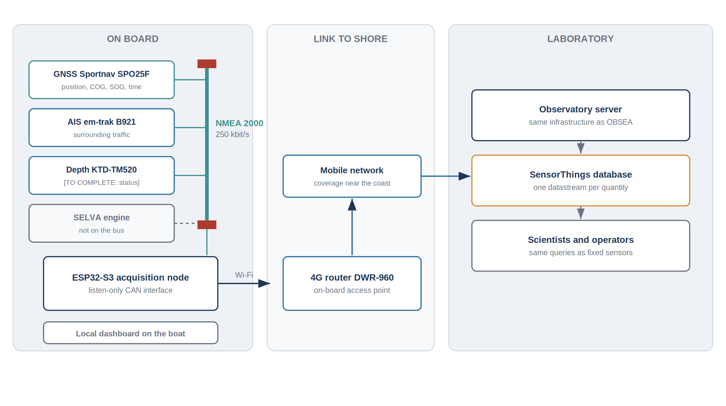
Figure 2: Overview of the acquisition chain, from the vessel equipment to the laboratory
The chain is deliberately simple. The acquisition node is a passive listener on the vessel network: it never transmits on the bus and draws no power from it, so a fault of the node cannot affect the navigation equipment. The node keeps the last known value of each quantity and forwards it through the on-board router, and a local page lets the crew check the values without any dependency on the mobile network.

5.1.1 Alternatives considered
Three families of solutions were compared before the hardware was chosen.
Table 5: Comparison of the candidate solutions
Option | Principle | Advantages | Drawbacks
A — Commercial NMEA 2000 gateway | A certified gateway converts the bus to NMEA 0183 or to a proprietary Ethernet protocol, an on-board computer forwards the result | No development, certified product | High cost per vessel, proprietary format, an on-board computer must be powered and maintained
B — Single-board computer with a CAN interface | A small Linux computer reads the bus through a CAN adapter | Great flexibility, easy logging | Consumption about ten times higher, sensitive to abrupt power cuts, risk of memory card corruption
C — Microcontroller with an integrated CAN controller | An ESP32-S3 reads the bus through an external transceiver and uses its own Wi-Fi radio | Low consumption, starts in about a second, no memory card, very low cost | Requires development and careful wiring

Option C was selected. On a small working vessel the power is cut abruptly every time the engine or the main switch is turned off, and a device that must shut down cleanly is not suited to that environment. The low cost per node also makes the installation reproducible on other vessels of the laboratory.

5.2 The instrumented vessels and their equipment
Two vessels were used during the internship: the Mar de Caroba for development and bench validation, and the Sei Whale for the production deployment. Both carry a comparable set of navigation and communication equipment, shown schematically below. The layout of the equipment matters for the project: the length of the cables, the position of the connection point and the protection of the node against water all depend on it.
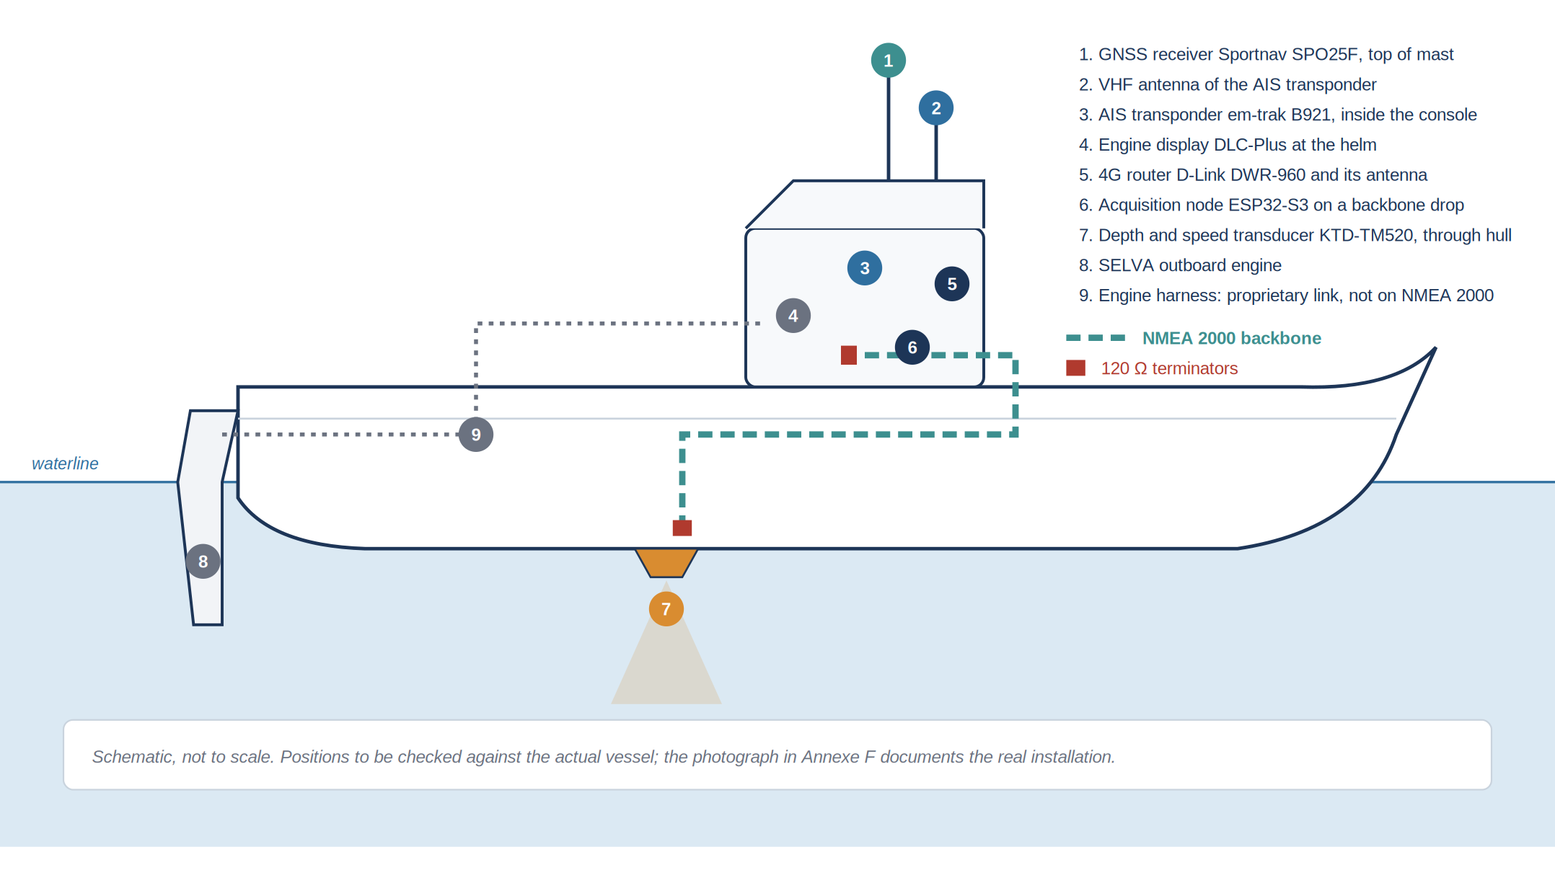
Figure 3: Position of the main equipment on board (schematic side view)
Table 6: Inventory of the on-board equipment
Device | Function | Link used | Connected to the NMEA 2000 backbone
Sportnav SPO25F | GNSS position receiver | NMEA 2000 | yes, transmitting
em-trak B921 | AIS class B transponder | NMEA 2000 and VHF antenna | yes, active only when the backbone is powered
KTD-TM520 | depth and speed transducer | [TO COMPLETE] | [TO COMPLETE: confirm]
SELVA outboard with DLC-Plus display | propulsion and engine monitoring | dedicated engine harness | no
D-Link DWR-960 | 4G router and Wi-Fi access point | Wi-Fi and mobile network | no, IP network

5.2.1 GNSS receiver
The Sportnav SPO25F is a satellite positioning receiver with an NMEA 2000 output. It is mounted high on the mast, with a clear view of the sky, because the quality of the position depends directly on the number of satellites received and on their geometry. It is the main source of data of the whole project: position, course and speed over ground, time and date, and indicators of the quality of the fix.
A GNSS receiver on a vessel does not measure the direction in which the bow points. It measures successive positions and deduces from them the direction and the speed of the movement. At very low speed, when the vessel is moored or drifting, the course over ground becomes erratic, because the displacement between two positions is of the same order as the position noise. That behaviour is normal and was observed at the quay; it must be kept in mind when the data are used.

5.2.2 AIS transponder
The Automatic Identification System is a maritime traffic system in which each equipped vessel broadcasts its identity, position, course and speed on two VHF channels. The em-trak B921 is a class B transponder: it both transmits the position of the vessel and receives the reports of the surrounding traffic. Class A equipment, mandatory on large commercial ships, reports more often and with more information than class B equipment, which is used on smaller vessels.
On the NMEA 2000 network, the transponder publishes the reports it receives from the other vessels: class A position reports in PGN 129038, class B position reports in PGN 129039, and the static data such as the name of the vessel in separate messages. For the laboratory, those reports are interesting because they turn the vessel into a mobile traffic observer: every trip records the positions of the ships met along the way.
A practical point was found during the installation: the NMEA 2000 interface of the transponder only becomes active when the backbone itself is supplied with 12 V. When the backbone is not powered, the transponder works normally on VHF but is invisible on the network.

5.2.3 Depth and speed transducer
The KTD-TM520 is a through-hull transducer. The depth is measured with an ultrasonic pulse: the transducer emits a short burst towards the seabed and measures the time taken by the echo to return. Knowing the speed of sound in sea water, about 1 500 m/s, that time gives the distance between the transducer and the seabed.
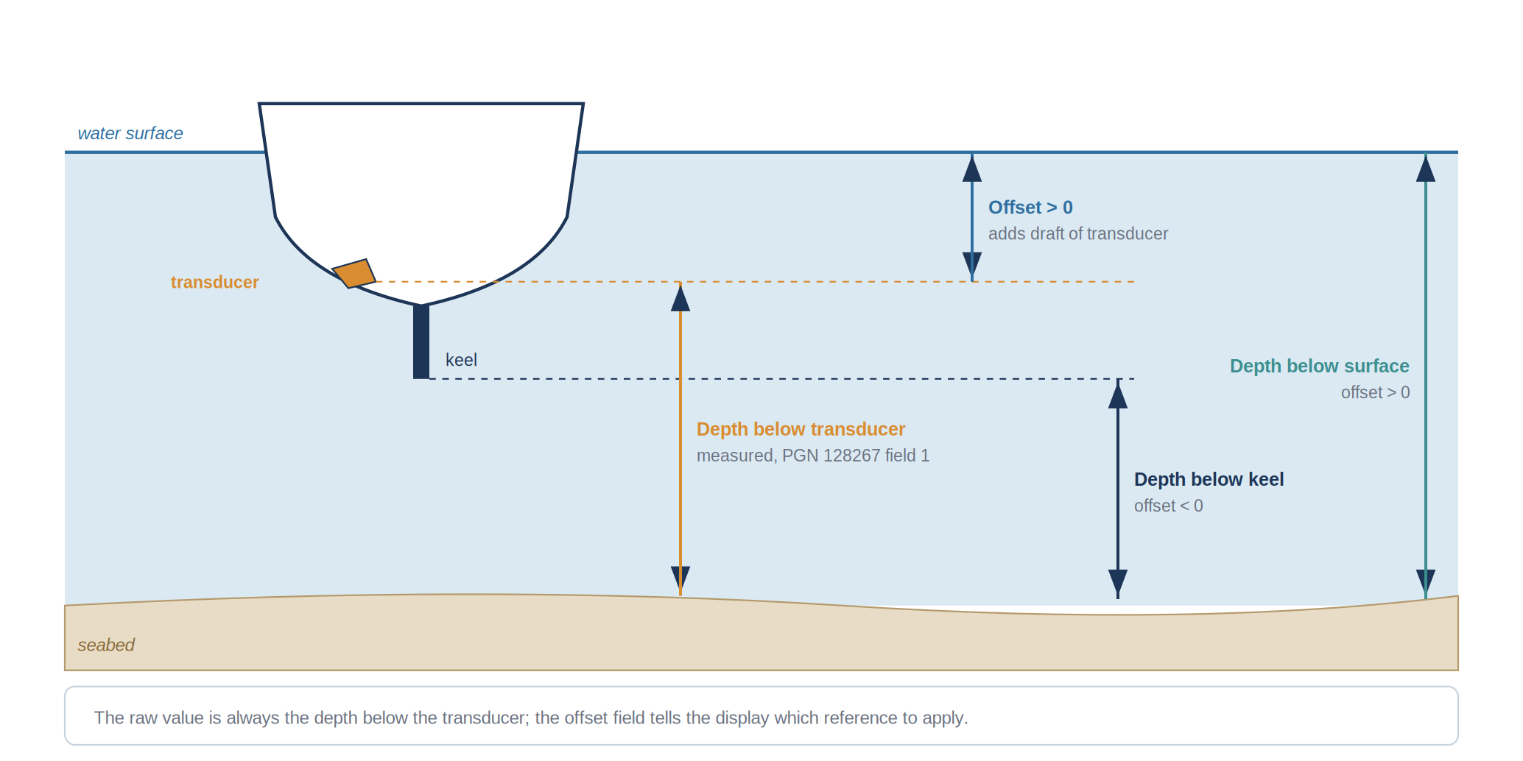
Figure 4: References used for the water depth and role of the offset
The measured distance is always the depth below the transducer, which is neither the depth of water nor the clearance under the keel. NMEA 2000 therefore transmits the raw depth together with an offset: a positive offset gives the depth below the surface, a negative offset gives the depth below the keel. Storing the raw value with its offset avoids any ambiguity on the reference used, which matters for a scientific use of the data. [TO COMPLETE: status of the transducer on the NMEA 2000 backbone, see Section 5.4.]

5.2.4 Engine and engine display
The SELVA outboard engine is monitored by a DLC-Plus display at the helm. The display receives engine speed, temperature and alarms through a dedicated harness supplied by the engine manufacturer. That harness is a proprietary link and is not connected to the NMEA 2000 backbone. The engine data are therefore visible on board but do not circulate on the network, a point that was established by the survey described in Section 5.4 and that changed the scope of the project.

5.2.5 Communications equipment
The D-Link DWR-960 is a 4G router that provides the on-board Wi-Fi network and the connection to the mobile network. It is the only path between the vessel and the laboratory. Its Wi-Fi access point operates on 2.4 GHz and 5 GHz, but the ESP32-S3 only supports 2.4 GHz, so the node must be associated with the 2.4 GHz network. The router gives the node a fixed address through a DHCP reservation based on its MAC address, which makes the node always reachable at the same address on board.

5.2.6 Navigation quantities and their meaning
Several quantities that look similar on a display are physically different, and confusing them makes the data wrong. The most important distinction is between the movement of the vessel through the water and its movement over the ground.
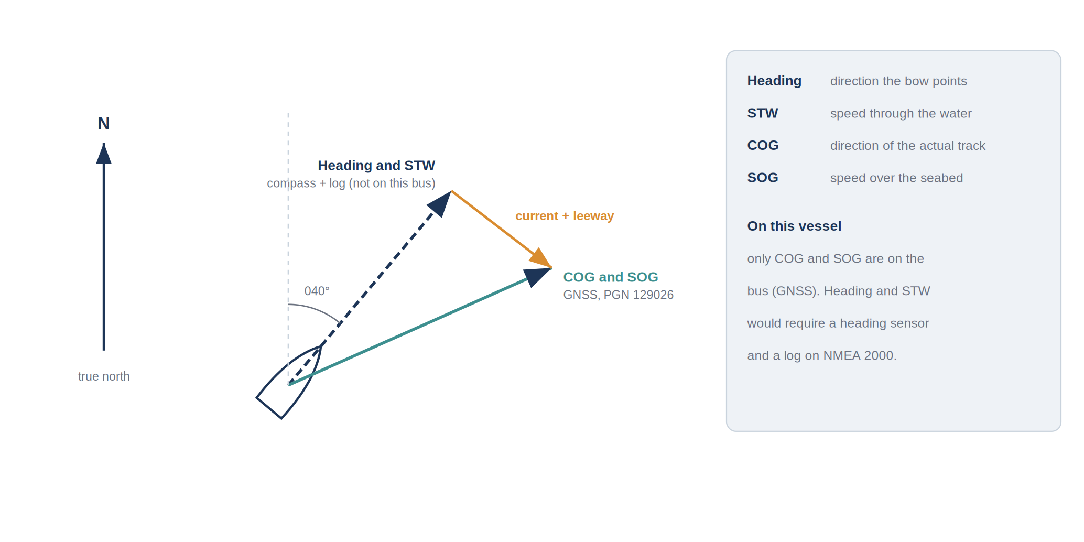
Figure 5: Heading and speed through the water compared with course and speed over ground
The heading is the direction in which the bow points, measured by a compass. The speed through the water is measured by a log, a small paddle wheel or an ultrasonic sensor under the hull. The course and speed over ground describe the real track of the vessel relative to the seabed and are given by the GNSS receiver. The difference between the two is caused by the current and by the wind drift, called leeway. On this vessel, only the course and speed over ground are available on the network. Heading and speed through the water would require a heading sensor and a log connected to the backbone; without them, the current cannot be deduced from the data.
Two other details concern angles. A heading or a course can be given relative to true north or to magnetic north; the difference, the magnetic variation, is about one degree to the east in the Vilanova i la Geltrú area. Each NMEA 2000 message that carries an angle states its reference in a dedicated field, and that field is checked before the value is stored.

5.3 The NMEA 2000 network

5.3.1 Principle
NMEA 2000 is the standard network for marine electronics published by the National Marine Electronics Association. It replaces the older NMEA 0183 standard, in which each talker was wired to its listeners through a point-to-point serial link. In NMEA 2000, all devices share a single cable, and each of them can send and receive data without any central equipment.
Table 7: Comparison of NMEA 0183 and NMEA 2000
Criterion | NMEA 0183 | NMEA 2000
Topology | one talker, several listeners, point to point | multi-talker, multi-listener bus
Speed | 4 800 bit/s, 38 400 bit/s for AIS | 250 kbit/s
Data format | ASCII sentences | binary messages identified by a PGN
Wiring | a dedicated cable for each link | a single backbone with drop cables
Power | each device has its own supply | the bus can power low-consumption devices
Adding a device | new cables and configuration | plug in a T-connector

The network is built on CAN, the bus developed for the automotive industry, and its message layer is derived from the ISO 11783 standard used on agricultural machinery, itself derived from the SAE J1939 standard of trucks. That origin explains the robustness of the network: CAN was designed to operate in environments with strong electrical noise, which is also the case on a vessel near an engine and a VHF transmitter.

5.3.2 Physical layer
The network has a linear structure. A main cable, the backbone, runs through the vessel and is closed at each end by a 120-ohm terminating resistor. Each device is connected to the backbone through a T-connector and a short drop cable. The terminators absorb the signal at the ends of the line and prevent reflections; a missing or doubled terminator is one of the most common faults of a marine network.
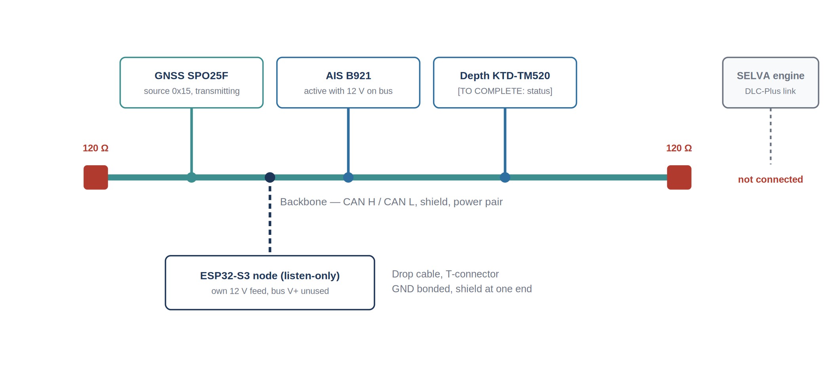
Figure 6: Backbone of the instrumented vessel, devices connected and position of the acquisition node
A simple check follows from that structure. With the network switched off, the resistance measured between CAN H and CAN L should be about 60 ohms, since the two 120-ohm terminators are in parallel. A value of 120 ohms means that a terminator is missing, a value of 40 ohms that there is one too many. That check was carried out before the node was connected [TO COMPLETE: measured value].
Table 8: Main limits of the physical layer
Parameter | Limit with standard micro cable
Bit rate | 250 kbit/s
Backbone length | 100 m
Length of one drop cable | 6 m
Total length of all drop cables | 78 m
Number of devices | 50 physical connections
Supply voltage on the bus | 9 to 16 V

The installation on the vessel is far below those limits: the backbone measures a few metres, and the drop cables are all shorter than two metres.

5.3.3 Power distribution
The backbone carries a power pair in addition to the data pair. It is supplied from the 12 V network of the vessel through a single power insertion point, protected by a fuse. Low-consumption devices can take their supply directly from the bus. The consumption of each device is expressed as a Load Equivalency Number, one unit corresponding to 50 mA, and the sum of the numbers must stay within the capacity of the power insertion point.
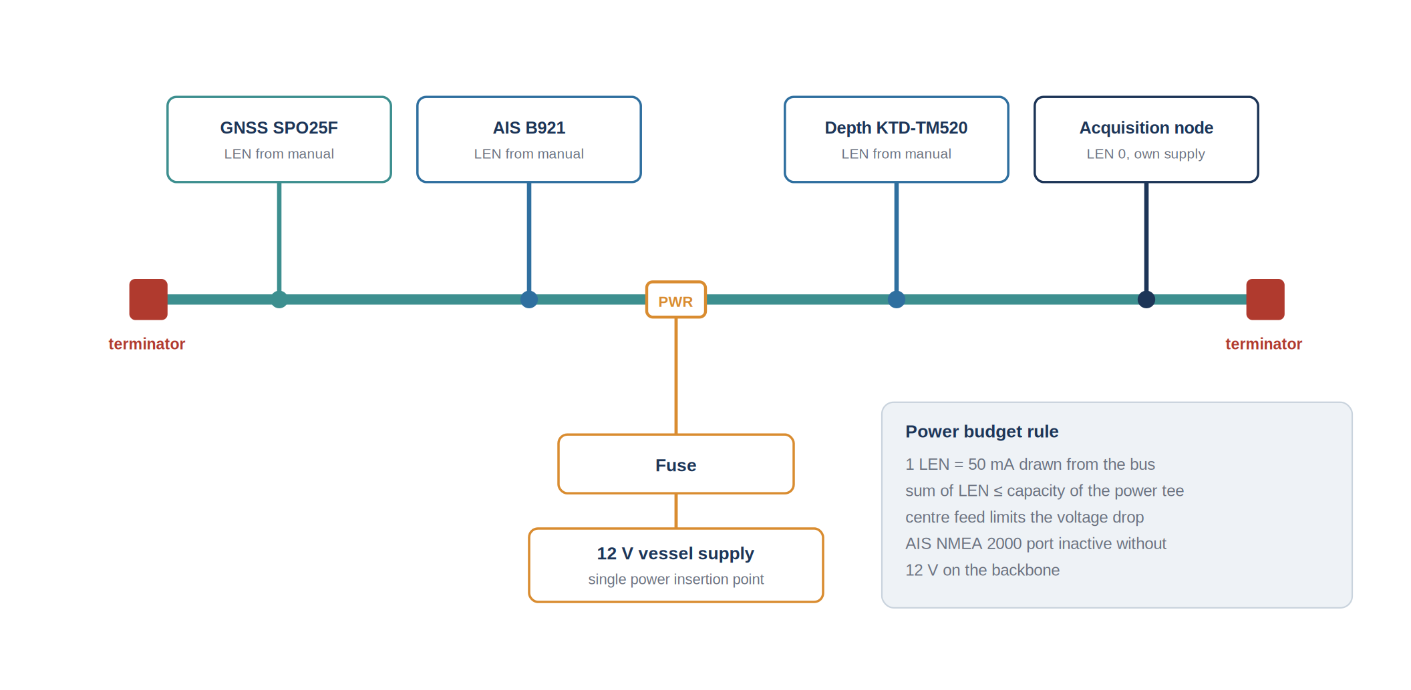
Figure 7: Power distribution on the backbone and load equivalency numbers
Table 9: Power budget of the backbone
Device | Load Equivalency Number | Current drawn from the bus
GNSS receiver SPO25F | [TO COMPLETE] | [TO COMPLETE]
AIS transponder B921 (NMEA 2000 interface) | [TO COMPLETE] | [TO COMPLETE]
Depth transducer KTD-TM520 | [TO COMPLETE] | [TO COMPLETE]
Acquisition node | 0 | none, the node has its own supply

Two decisions follow from this. First, the acquisition node is not supplied by the bus: its supply comes from the 12 V network through its own regulator, so it adds no load and cannot pull the bus voltage down. Second, the power state of the backbone determines which devices are visible, as the AIS transponder shows: when the backbone is not supplied, its NMEA 2000 interface stays silent even though the transponder is working.

5.3.4 Connectors and wiring
NMEA 2000 uses circular M12 connectors with five pins, called micro-C in the marine industry. They are sealed and screwed, which protects the contacts against water and vibration. The pinout and the colour code are fixed by the standard.
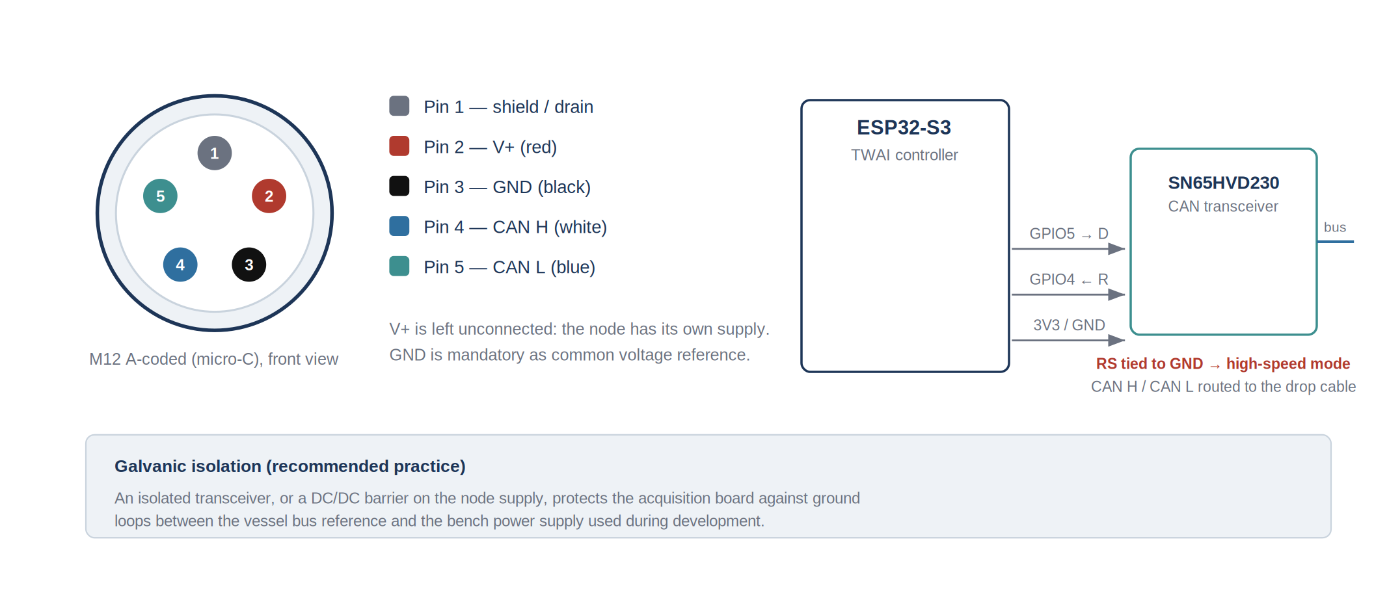
Figure 8: M12 five-pin pinout and connection of the acquisition node
The pinout was checked with a multimeter before any connection, because an inversion of CAN H and CAN L produces no damage and no error message: the bus simply stays silent for the node, and the fault is easily blamed on the software. The shield is connected at one end only, to avoid ground loops. The power conductor of the drop cable is left unconnected, since the node has its own supply. The ground conductor, on the other hand, must be connected: the transceiver measures a voltage difference between CAN H and CAN L, and without a common ground reference the voltages can drift out of its input range, which causes intermittent reception faults.

5.3.5 Messages on the network
Every message on the bus carries an identifier made of three pieces of information: a priority, a Parameter Group Number that says what the message contains, and the address of the device that sent it. The PGN is the key to reading the network: a receiver that knows the list of PGNs and their layout can interpret the traffic of any certified device, whatever its manufacturer.
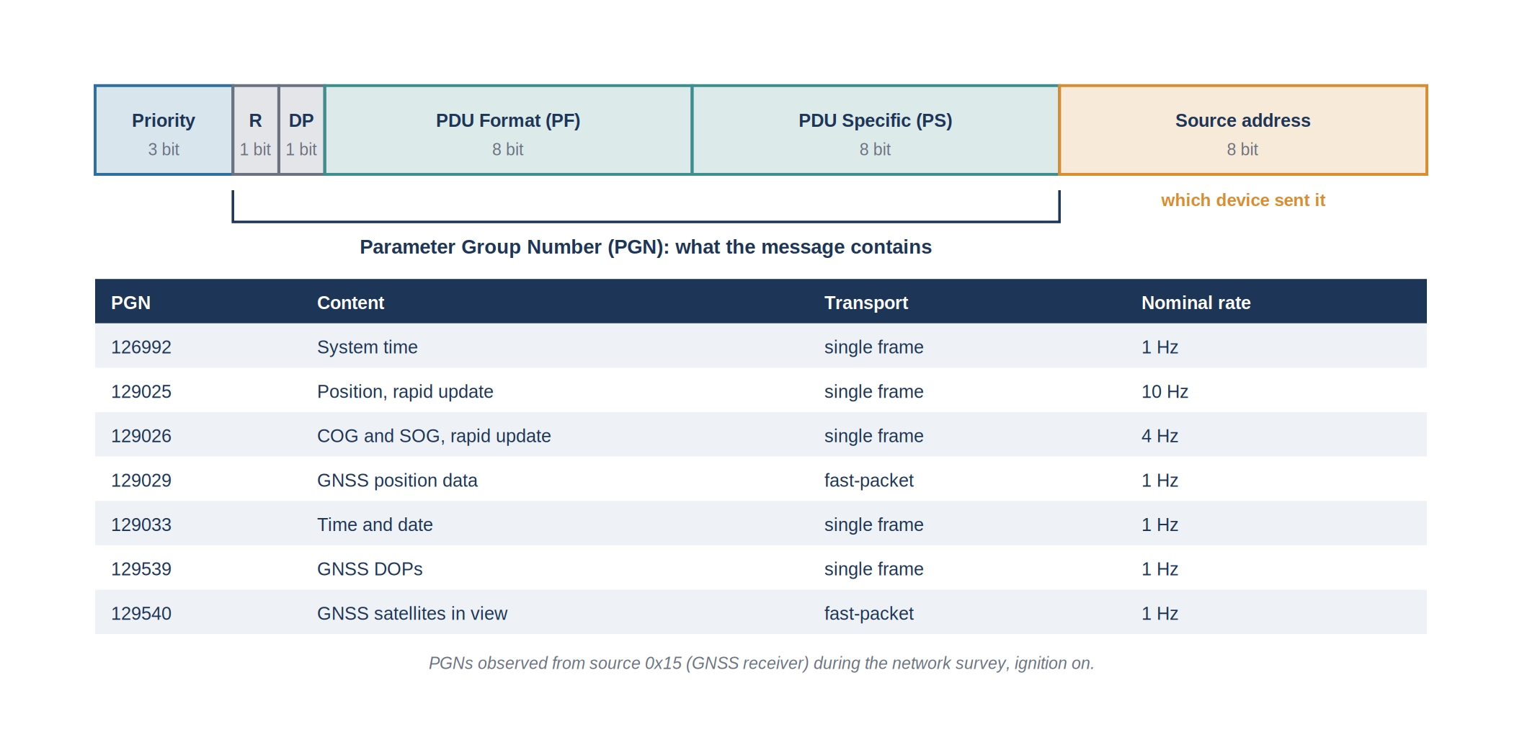
Figure 9: Structure of the identifier and parameter groups sent by the GNSS receiver
A CAN frame carries at most eight bytes of data. That is enough for a position or a speed, but not for a complete GNSS fix or an AIS report. Those longer messages are cut into a sequence of frames, a mechanism called fast-packet, and the receiver must put the pieces back together in the right order.
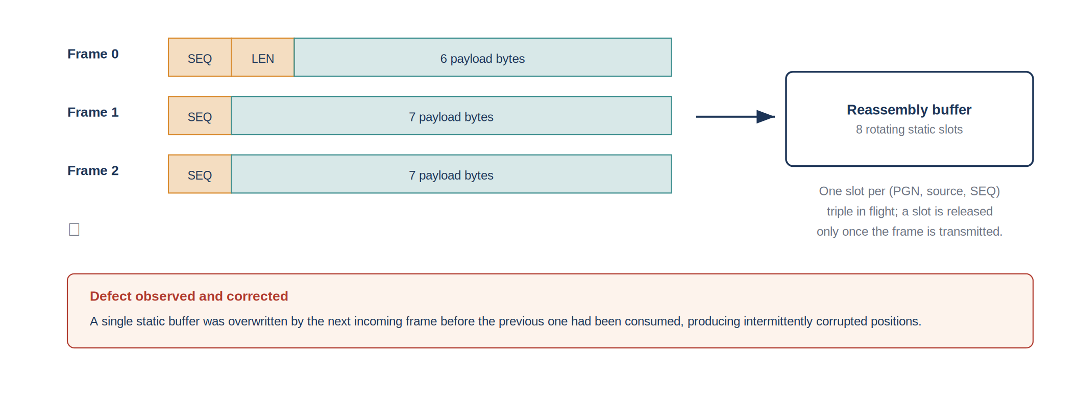
Figure 10: Fast-packet transport of a message longer than eight bytes
Each device also takes part in the management of the network. At power-on it claims an address and announces a unique name, and it can describe itself on request, with its manufacturer, model and software version. The address of a device can change from one power-on to the next if another device claims it first, so it cannot be used as a permanent identifier of an instrument. The product information message, PGN 126996, is the reliable way to know which device hides behind an address.

5.4 Survey of the existing network
The equipment list of the vessel says what is installed, not what is on the network. Before any decoding work, the traffic actually present on the backbone was therefore recorded and analysed. That survey is the most important step of the project, because it replaced assumptions with observations.

5.4.1 Method
The acquisition node was connected to the backbone in listen-only mode, the ignition was switched on, and every frame received was recorded for several minutes. The frames were then grouped by source address and by PGN, and the number of frames of each group was divided by the recording time to obtain the rate. The backbone voltage and the resistance between CAN H and CAN L were measured beforehand.

5.4.2 Results
Table 10: Traffic observed on the backbone, ignition on
Source address | PGN | Content | Observed rate
0x15 | 129025 | Position, rapid update | [TO COMPLETE]
0x15 | 129026 | Course and speed over ground | [TO COMPLETE]
0x15 | 129029 | Complete GNSS position | [TO COMPLETE]
0x15 | 129033 | Time and date | [TO COMPLETE]
0x15 | 126992 | System time | [TO COMPLETE]
0x15 | 129539 | Dilution of precision of the fix | [TO COMPLETE]
0x15 | 129540 | Satellites in view | [TO COMPLETE]

The result was clear: a single device, at address 0x15, transmitted on the network, and that device was the GNSS receiver. No engine message, no depth message and no AIS message was present.
Table 11: Expected quantities compared with the survey
Quantity | Expected source | Found on the bus | Consequence
Position, course, speed over ground | GNSS receiver | yes | acquired
Time and date | GNSS receiver | yes | used as the time reference
Fix quality, satellites | GNSS receiver | yes | acquired, used to qualify the position
Surrounding traffic | AIS transponder | only with 12 V on the backbone | acquired when the backbone is powered
Water depth, speed through water | depth transducer | no | [TO COMPLETE: explanation]
Engine speed, temperature, alarms | SELVA engine | no, engine not connected | engine datastreams created but empty
Heading | heading sensor | no, no sensor installed | not available

Three conclusions were drawn. First, the engine data displayed at the helm do not exist on the network: obtaining them requires an engine gateway that converts the manufacturer's link into NMEA 2000 messages. Second, the presence of a device on the network depends on its power state, which must be documented for every vessel. Third, the positioning data are complete and of good quality, which made it possible to focus the project on them without waiting for new equipment.

5.4.3 Load of the network
The survey also made it possible to estimate the occupation of the bus.
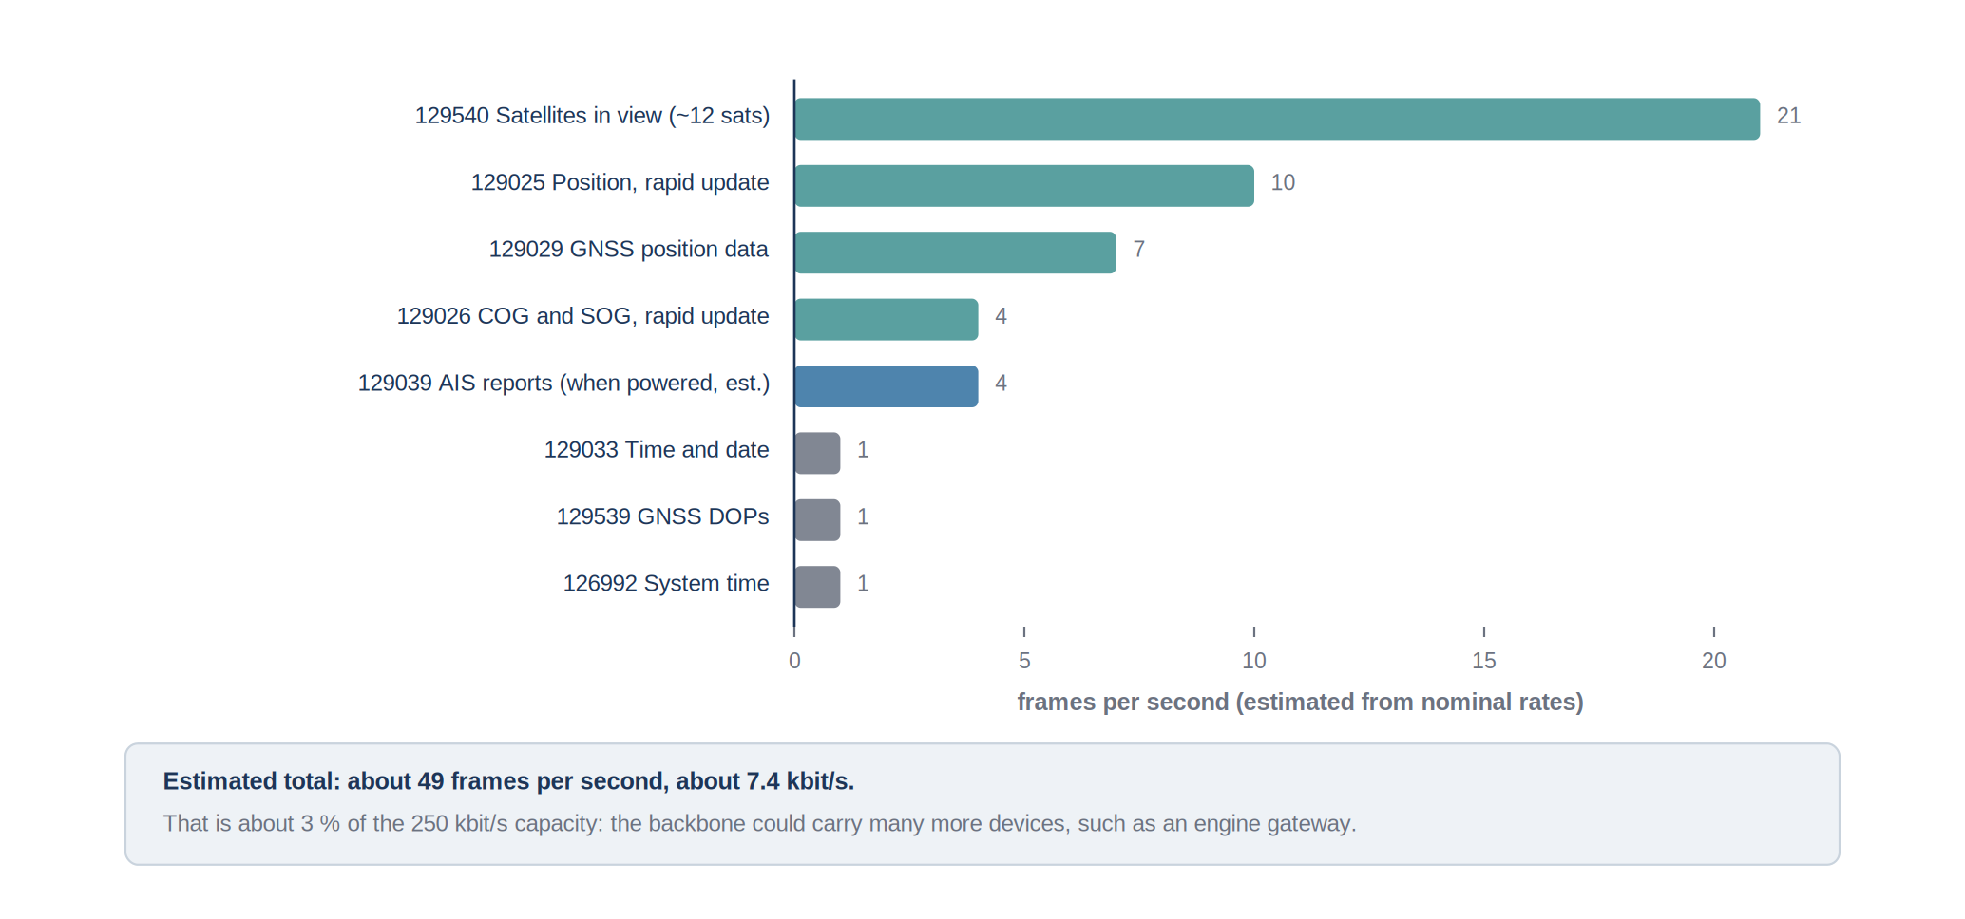
Figure 11: Estimated frame rate of each parameter group and load of the backbone
The largest contribution comes from the list of satellites in view, a long message cut into about twenty frames every second. Even so, the traffic represents about 3 % of the capacity of the bus. The network could receive many more devices, including an engine gateway and a heading sensor, without any risk of saturation. The frames are however not evenly spread: the receiver sends its messages in bursts, which caused one of the faults described in Section 5.9.

5.5 Connection of the acquisition node

5.5.1 Choice of the connection point
The node is connected to a free T-connector of the backbone, near the console. That position was chosen for three reasons: the drop cable is short, well under the six-metre limit; the router is close, so the Wi-Fi link is strong; and the console is the driest and most protected part of the vessel. [TO COMPLETE: length of the drop cable and exact position.]

5.5.2 Electrical interface
The ESP32-S3 contains a CAN controller but cannot be connected directly to the bus, whose voltage levels are different from those of the microcontroller. An SN65HVD230 transceiver makes the conversion between the differential signals of the bus and the logic levels of the microcontroller. Its RS pin must be tied to ground to select the high-speed mode; left floating, it places the circuit in a low-power state in which frames are not received.
The node is configured in listen-only mode. It receives every frame but never sends anything, not even the acknowledgement bit that CAN normally requires. The node therefore cannot disturb the traffic, does not need to claim an address, and does not need to be certified. That choice was made on purpose: on a working vessel, the navigation equipment must keep working whatever happens to an experimental device.
Galvanic isolation between the node and the bus is recommended, because the ground of the vessel network and the ground of a bench supply are not always at the same potential. An isolated transceiver would remove that risk and is recommended for a permanent installation.

5.5.3 Power supply
Table 12: Power budget of the acquisition node
Contribution | Typical value | Remark
Microcontroller, radio active | about 120 mA at 3.3 V | during Wi-Fi transmissions
Microcontroller, radio idle | about 40 mA at 3.3 V | between transmissions
CAN transceiver | about 10 mA at 3.3 V | independent of the traffic
Converter efficiency | about 85 % | from 12 V to 5 V
Mean consumption on the 12 V network | about 1 W | negligible compared with the navigation equipment

The node takes about one watt from the 12 V network, which is negligible compared with the navigation electronics and the engine. It starts in about one second after power-on, so it is operational as soon as the vessel is.

5.5.4 Installation constraints
A vessel is a hard environment for electronics, and three constraints were identified for a permanent installation. Humidity and salt spray require a sealed enclosure with cable glands, even inside the console. Vibration loosens connectors before it damages components, so locking connectors or screw terminals must replace the pin headers used on the bench. Temperature can rise well above the ambient value in a closed console exposed to the sun, and the operating range of the components must be checked against that condition.

[ INSERT: Photograph of the acquisition node installed in the console ]
Figure 12: Acquisition node installed on board, connected to the backbone through a T-connector

5.6 Decoding the navigation data
Each message is decoded according to the layout defined for its PGN. All values are transmitted as whole numbers with a fixed scale factor; a special value, usually the largest possible number, means that the data are not available. That value must be recognised and discarded, otherwise a missing depth would be stored as a depth of several hundred million metres.
Table 13: Quantities decoded and their conversion
PGN | Quantity | Resolution on the bus | Unit stored
129025 | latitude, longitude | 1e-7 degree, about 1 cm | degree
129026 | course over ground | 1e-4 radian | degree
129026 | speed over ground | 0.01 m/s | metre per second
129029 | altitude, fix type, satellites used | 0.000001 m | metre
129539 | horizontal dilution of precision | 0.01 | dimensionless
129540 | satellites in view, signal strength | 0.01 dB | decibel
129033 | date and time | days since 1970 and 0.0001 s | ISO 8601 date and time
129038 / 129039 | position and course of AIS targets | 1e-7 degree and 1e-4 radian | degree

5.6.1 Position and quality of the fix
The position is sent twice. PGN 129025 carries only the latitude and longitude, ten times per second, in a single frame. PGN 129029 carries the complete fix once per second: position, altitude, type of fix and number of satellites used, in a multi-frame message. The fast message is used for the position, and the complete message for the quality information. When a multi-frame message arrives incomplete, which happens when a frame is lost, it is rejected rather than allowed to overwrite a good position.
The quality of the fix is published alongside the position. The horizontal dilution of precision, taken from PGN 129539, expresses how the geometry of the satellites amplifies the measurement errors: a value close to 1 indicates a good geometry, a value above 5 a degraded one. Together with the number of satellites, it allows a user of the data to discard doubtful positions afterwards.

5.6.2 Course and speed over ground
PGN 129026 carries the course and the speed over ground four times per second. The course is transmitted in radians and converted into degrees, and its reference, true or magnetic, is read from the message. The speed is transmitted in metres per second, the unit kept in the database, and converted into knots only for the display on board, since one knot is 0.514 m/s. As explained in Section 5.2, the course is only meaningful when the vessel is actually moving.

5.6.3 Time reference
Every stored value needs an accurate date and time. The GNSS receiver provides them through PGN 129033 and PGN 126992, derived from the atomic clocks of the satellites. During the first bench tests, however, no time message was received, and the node could not date its first measurements. A second source was therefore added: the node synchronises its clock with a time server over the network as soon as the router is connected. The survey later confirmed that the receiver does send its time messages on the vessel, so GNSS time is the main reference and the network time is a backup. The time used for each value is the time of its reception on the bus, not the time of its transmission to shore, so that a delay on the mobile link does not distort the time series.

5.6.4 AIS reports
The AIS position reports are long messages sent in several frames. Their layout on NMEA 2000 is the native binary format of the standard, with latitude and longitude as whole numbers in units of 1e-7 degree and the course in units of 1e-4 radian; it is not the bit-packed format used on the VHF radio link, which was a source of confusion at the start. Each target is identified by its MMSI, the nine-digit maritime identity of the vessel, and its name is obtained from the static data messages. The node keeps a table of the targets received, with the time of the last report, and removes targets that have not been heard for several minutes.
Several faults were met while writing and testing the decoding on the real network; they are described with their resolution in Section 5.9.

5.7 On-board connectivity and link to the laboratory

5.7.1 Mobile link
The only link between the vessel and the laboratory is the 4G router. The mobile coverage is good in the harbour and along the coast, but decreases with the distance from the shore. When the link is lost, the node keeps acquiring and keeps updating the local display; the values produced during the outage are not transmitted to the laboratory. The reconnection is automatic when coverage returns. [TO COMPLETE: distance from the coast at which the link was lost during the sea trials, if observed.]

5.7.2 Local display for the crew
The node also serves a web page on the on-board network, which any phone or tablet connected to the Wi-Fi can open. It shows the position, the course and speed, the quality of the fix, the time and the list of AIS targets, with the age of each value so that an old value is immediately recognisable.
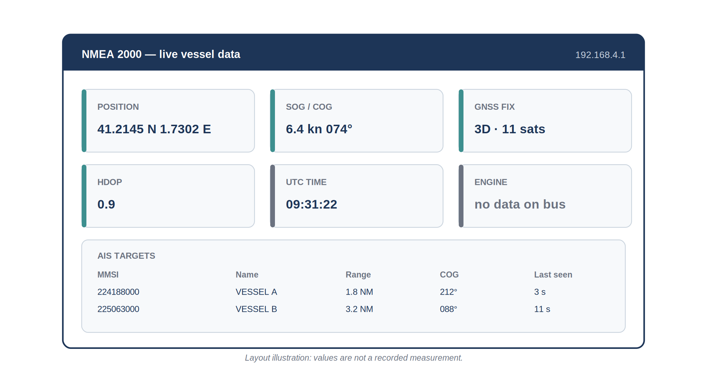
Figure 13: Layout of the local display served by the node on the on-board network
The engine box of the display indicates that no engine data are present on the network, rather than showing zero: a missing value and a zero value must never be confused, on the display as in the database.

5.7.3 Storage in the observatory database
At the laboratory, the values are stored in the database already used for the fixed sensors of the OBSEA observatory. It follows the OGC SensorThings standard, which organises the data simply: the vessel is a Thing, it has a Location, and each measured quantity is a Datastream to which the successive Observations are attached, each with its value and its date.
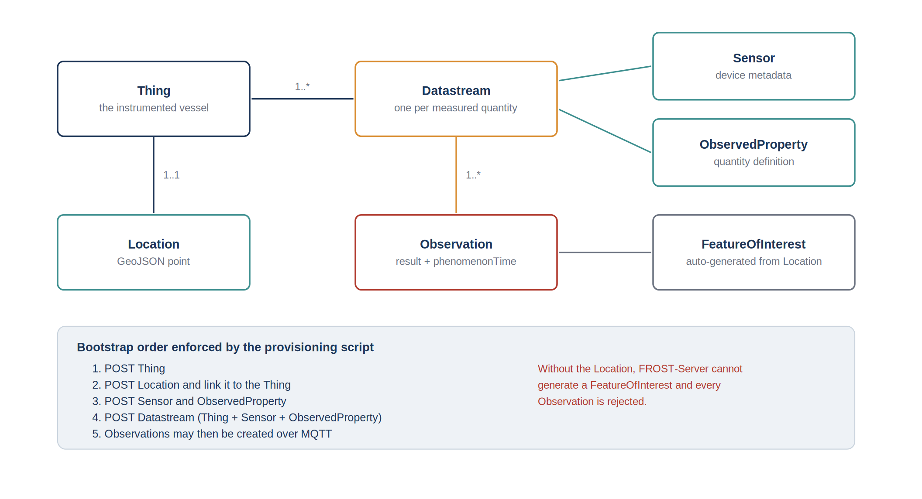
Figure 14: Organisation of the data in the observatory database
Table 14: Datastreams declared for the vessel
Datastream | Unit | Source | State
Position | degree | PGN 129025 | receiving data at 1 Hz
Speed over ground | metre per second | PGN 129026 | receiving data
Course over ground | degree | PGN 129026 | receiving data
Fix quality and satellites | dimensionless | PGN 129029, 129539 | [TO COMPLETE]
Engine speed | revolution per minute | engine gateway required | created, empty
Coolant temperature | degree Celsius | engine gateway required | created, empty

The engine datastreams were created during the initial setup, when the engine was assumed to be on the network. They were kept, empty, so that the installation of an engine gateway will only require a configuration change on the node. The position observations are confirmed to be arriving in the production database at the rate of one per second.
One technical constraint of the server is worth noting because it cost time: the database refuses every value from a vessel that has no Location declared, since it cannot place the measurement anywhere. The declaration of the vessel was therefore scripted in a fixed order, Location included, before the first value is sent.

5.8 Installation on board and validation

5.8.1 Installation procedure
The installation was written as a procedure, so that it can be repeated on another vessel without the author.
Table 15: Installation procedure of the node
Step | Operation | Check
1 | Switch off the network and measure between CAN H and CAN L | about 60 ohms
2 | Switch on and measure the backbone voltage | between 9 and 16 V
3 | Check the pinout of the drop cable | CAN H pin 4, CAN L pin 5, ground pin 3
4 | Connect the node to a free T-connector, supply it from the 12 V network | node starts within a second
5 | Record the traffic for a few minutes | list of sources and PGNs as expected
6 | Connect a phone to the on-board Wi-Fi and open the local page | live values with a small age
7 | Query the database from the laboratory | new observations every second

5.8.2 Validation strategy
The validation was carried out in three stages of increasing realism, each one only started when the previous one was successful, so that a fault could always be linked to what had just been added.
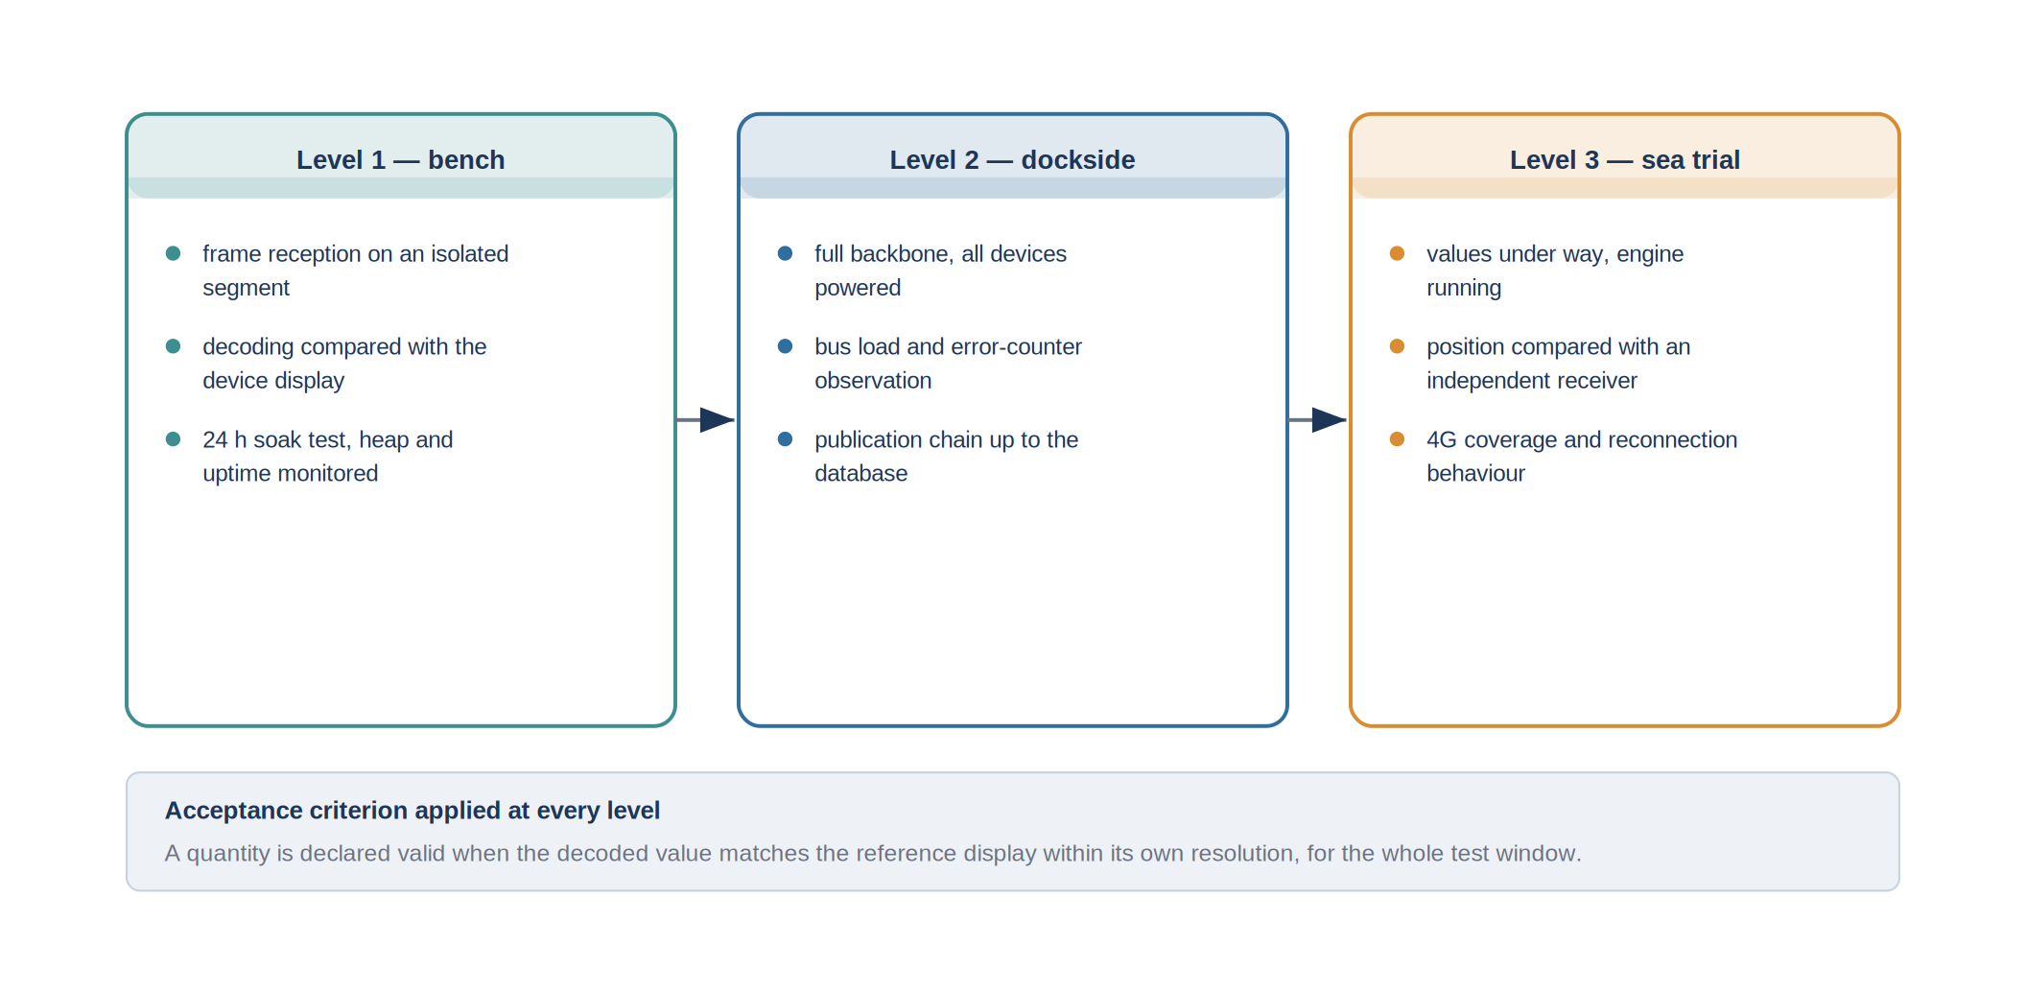
Figure 15: Three-stage validation, from the bench to the sea trial
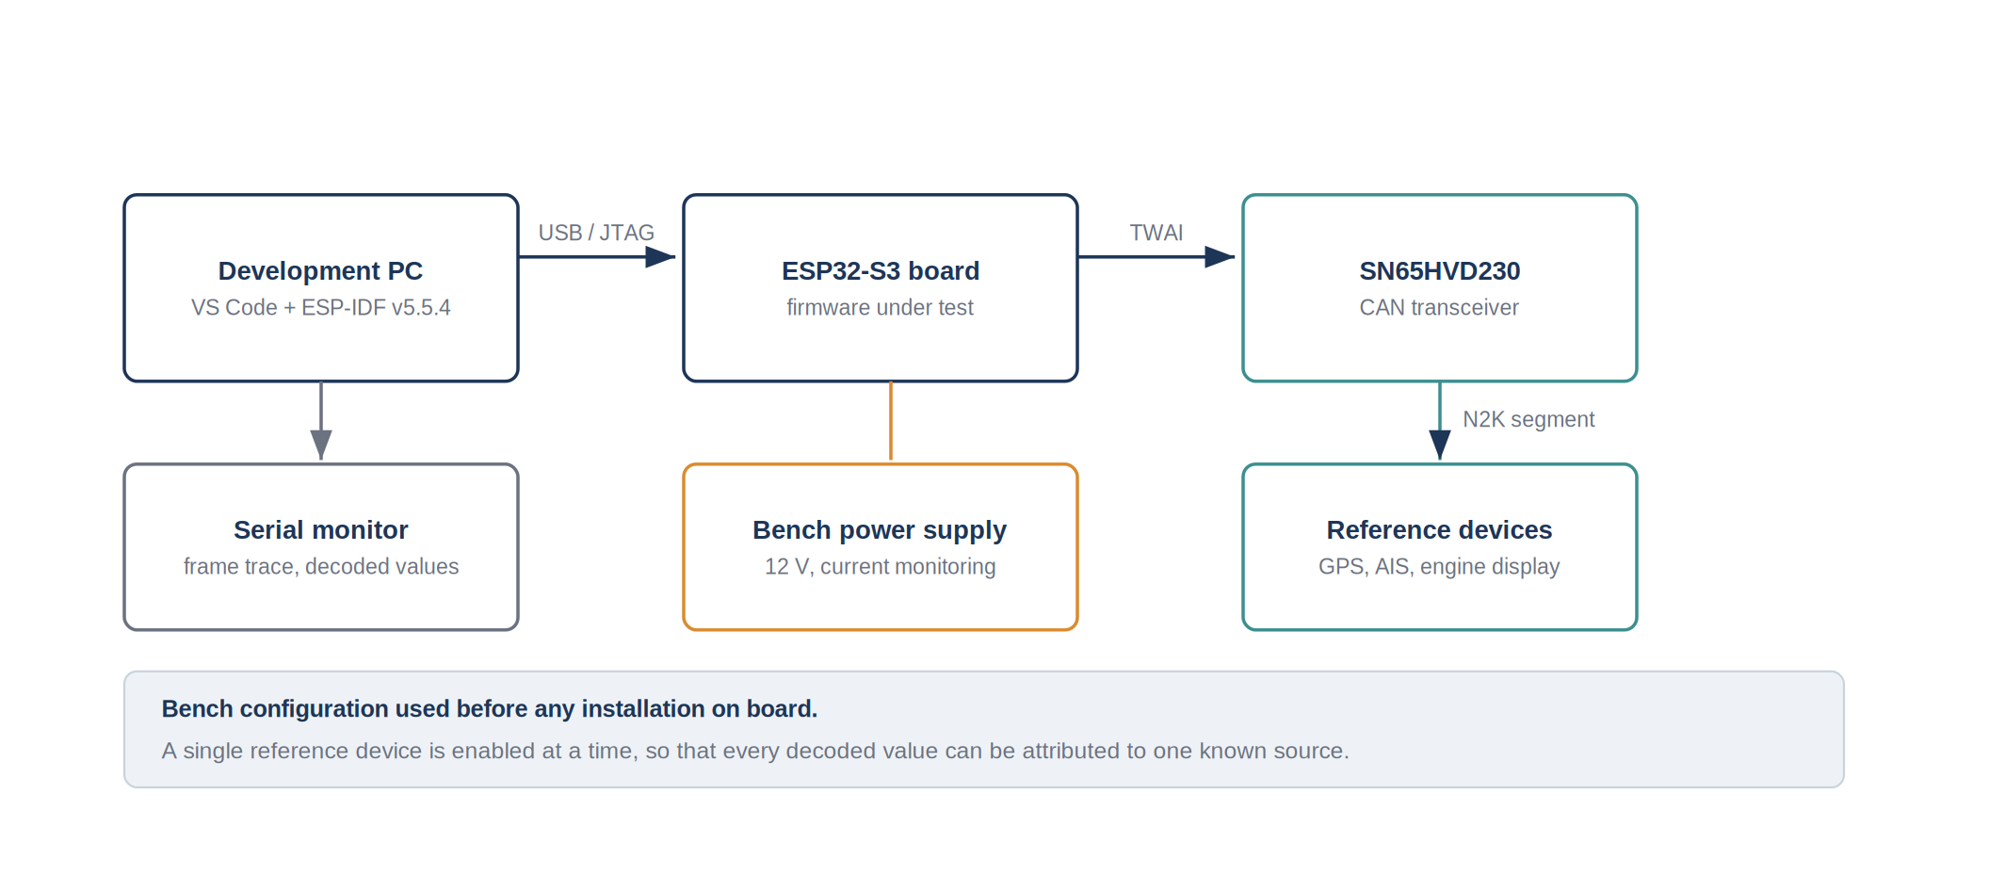
Figure 16: Bench configuration used before installation on board
On the bench, a single device was connected at a time and each decoded value was compared with its own display. At the quay, the node was connected to the complete network with every device switched on; that is where the bursts of traffic and the behaviour of the AIS interface appeared. At sea, the vessel was under way, the position changed, and the mobile link could be tested with the distance from the coast.

5.8.3 Measurement method
The reference used for the comparisons is the display of the same device, not an instrument of higher accuracy. The comparison therefore validates the acquisition and the transmission, not the accuracy of the sensors themselves. The readings are also not simultaneous: the display and the node refresh at different moments, so for a quantity that varies quickly the observed difference mostly reflects that delay. The comparisons were therefore made in stable conditions: at rest for the position, and at constant speed and course for the speed and course over ground.
Table 16: Results of the acceptance tests
Ref. | Test | Result | Comment
F1 | Position, course and speed compared with the on-board display | [TO COMPLETE: pass or fail] | [TO COMPLETE: observed difference]
F1 | Engine parameters | not applicable | engine not connected to the network
F2 | AIS targets compared with an independent receiver | [TO COMPLETE] | [TO COMPLETE: number of targets compared]
F3 | Observations retrieved from the database | verified | position observations present in the production database
F4 | Date and time of each value | verified | GNSS time, network time as backup
F5 | Local display on the on-board Wi-Fi | verified | opened from a phone on the vessel network
F6 | Recovery after loss of the link or of the power | [TO COMPLETE] | [TO COMPLETE: recovery time]
N1 | One value per second for each quantity | verified | confirmed on the production database
N3 | No effect on the existing equipment | verified | listen-only node, no load on the bus

5.8.4 Interpretation
The acquisition chain works for the data really present on the network: the position, course, speed, time and quality of the fix of the vessel reach the laboratory database every second, and the crew can see them on board without depending on the mobile link. The AIS reports are acquired when the backbone is powered. The engine requirement cannot be met with the current equipment, not because of the acquisition chain, but because the engine is not connected to the network; that is a result of the survey, and it defines the first improvement to make.

5.9 Problems encountered and their resolution
Reaching the final result required solving a series of problems, met in the order in which the data travel: first the wiring, then the content of the network, the decoding, the link to shore and finally the database. Each problem was handled with the same method: describe the symptom precisely, form a hypothesis, test it by changing a single element at a time, correct, and check the correction on the complete network and not only on the bench.
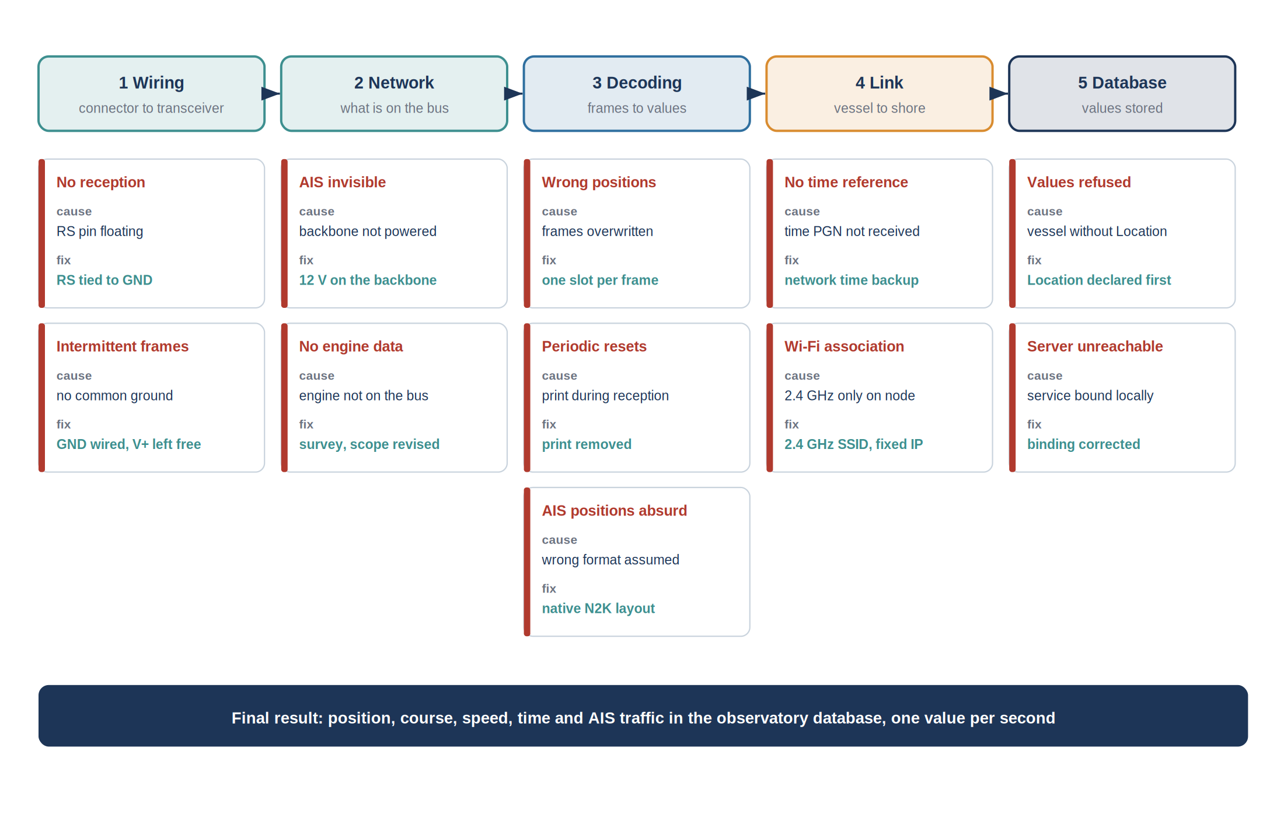
Figure 17: Problems met along the chain, their cause and their resolution

5.9.1 Wiring and physical connection
No reception at all. When the node was first connected, it received no frame, although the GNSS receiver was working and its data appeared on the display. The software was suspected first. Measuring the voltages on the transceiver showed that the circuit was not in its normal operating mode: its RS pin, which selects the speed mode, was left unconnected, which puts the SN65HVD230 in a low-power standby state. Tying the RS pin to ground put the transceiver in high-speed mode, and the first frames were received immediately.
Intermittent reception. With some wiring configurations, frames were received for a while and then lost, without any apparent pattern. The drop cable had been wired with only CAN H and CAN L, on the idea that the node had its own supply and did not need anything else from the bus. The transceiver, however, measures CAN H and CAN L relative to its own ground; without a ground shared with the network, the two references drift apart and the signals leave the input range of the circuit. Connecting the ground conductor of the drop cable, while leaving the power conductor free, made the reception stable. The same check was then added to the installation procedure.

5.9.2 Content of the network
AIS transponder invisible. The transponder was clearly working, since its VHF indicators were active, but none of its messages appeared on the bus. The documentation and a test with the backbone supplied from a bench power supply showed that its NMEA 2000 interface only starts when the backbone itself receives 12 V. On the development bench the backbone was not supplied, because the GNSS receiver had its own power. Supplying the backbone made the AIS messages appear at once. The power state of the backbone is now part of the installation checks.
No engine data. The engine speed and temperature were displayed at the helm, and engine messages were expected on the network. None was ever received. Rather than looking for an error in the decoding, the complete traffic was recorded, as described in Section 5.4, with the ignition on. The recording showed a single transmitting device, the GNSS receiver, and no engine message at all. Following the cables confirmed the cause: the DLC-Plus display is connected to the engine through a dedicated harness from the manufacturer, which is not linked to the NMEA 2000 backbone. The problem could not be solved by software. It was solved at the level of the project: the scope was revised with the tutor to focus on the data actually present, the engine datastreams were kept empty so that no reconfiguration of the database will be needed later, and the engine gateway was identified as the first improvement to make.

5.9.3 Decoding
Wrong positions. On the bench, with the GNSS receiver alone, the positions were correct. On the complete network, some positions were wrong by several kilometres, at random, a few times per hour. Because the fault was rare, it was first attributed to the receiver. Comparing the recorded frames with the decoded values showed that the frames themselves were correct and that the error appeared inside the node: when several frames arrived within a fraction of a millisecond, the storage area used for one frame was reused for the next before the first had been read. The correction gives each incoming frame its own slot, from a pool of four slots for single frames and eight for multi-frame messages, sized from the largest burst observed. No wrong position was observed after the correction [TO COMPLETE: duration of observation].
Periodic resets of the node. The node restarted by itself every few minutes. A power supply problem was suspected and a laboratory supply was used instead of the vessel supply, without any change. The reset reason reported by the microcontroller pointed to a software fault, and the fault was traced to a diagnostic message printed at the exact moment a frame was received. At that moment the microcontroller must not wait for anything, and printing a message does wait for the serial port. Removing that print, and replacing it by counters read later, stopped the resets.
Corrupted complete fix. Occasionally, a complete GNSS message, sent in seven frames, arrived with a missing frame and was reassembled with wrong content, overwriting a good position received a few milliseconds earlier. The rule adopted takes the position only from the single-frame message 129025, and the complete message only for the quality of the fix; an incomplete message is rejected. A position is also rejected if it implies a jump that the vessel could not have made in the elapsed time.
AIS positions far away. The first decoded AIS targets appeared hundreds of kilometres from the vessel. The decoding had been written after documentation of the AIS radio messages, in which the bits are packed differently. On NMEA 2000, the transponder publishes the report in the native binary layout of the network, with latitude and longitude as whole numbers in units of 1e-7 degree and the course in units of 1e-4 radian. Rewriting the decoding according to that layout gave positions consistent with the traffic visible from the harbour.

5.9.4 Time and connectivity
No time reference. During the first bench tests, the node received no time message from the GNSS receiver, and the values could not be dated, which the database does not accept. Rather than wait, a second time source was added: the node synchronises its clock with a public time server as soon as the router is connected. The survey later showed that the receiver does send its time messages on the vessel. GNSS time is therefore used first, and network time as a backup, so that the node can always date its values.
Wi-Fi association. The node sometimes failed to join the on-board network, and its address changed from one start to the next, which made it hard to reach from a laptop. The ESP32-S3 only supports the 2.4 GHz band, so the node was configured on the 2.4 GHz network of the router, and a DHCP reservation was created on the router so that the node always receives the same address.

5.9.5 Database at the laboratory
Values refused by the database. When the first values were sent, every one of them was refused, while the node reported a successful transmission. The server logs showed that the database could not attach the values to a location. In the SensorThings model, each value must be linked to what was observed, which the server deduces from the Location of the vessel; the vessel had been declared without one. Declaring the Location first, and then the other elements in a fixed order, solved the problem. That order is now written in a script so that it cannot be forgotten on the next vessel.
Declaration of the vessel through the messaging link. The values are sent through a lightweight messaging protocol, well suited to a mobile link. That protocol can only add new values: it cannot declare the vessel, its sensors and its quantities. Those declarations are therefore made once, through the web interface of the server, before the node starts sending.
Server unreachable from outside. Once installed, the database answered on the server itself but not from outside the laboratory. The service had been configured to accept connections only from the server itself, while the front web server reaches it through the internal network of the containers. Opening the service to that internal network, while keeping it closed to the outside, made it reachable through the public address of the observatory. This problem was solved with the help of the administrator of the infrastructure.

5.9.6 Lessons drawn
Three rules come out of these problems and are applied in the installation procedure. First, the survey of the network comes first: most of the time lost in the project was spent looking for data that did not exist on the bus. Second, a test with a single device on a short cable is not enough; the complete network, with all its devices powered, must be used as early as possible, because several faults only appeared there. Third, each fault must be observable from the node itself: the node now counts the frames received, the frames lost, the messages rejected and the restarts, and each counter that should stay at zero is shown on the local page, so that a new fault is noticed at once and dated.

5.10 Critical analysis
With hindsight, the most important lesson is the order of the work. The survey of the network should have been the very first task, before any decoding work. Several days were spent preparing the decoding of engine and depth messages that did not exist on the bus. On any future vessel, the procedure starts with a recording of the traffic.
The listen-only choice is confirmed. It protected the navigation equipment during all the tests, including the periods when the node was restarting because of the faults described above, and it avoided the need for a certification that would have been impossible within ten weeks.
The independent power supply of the node is also confirmed: it made the node visible and testable whatever the power state of the backbone, which is precisely what revealed the behaviour of the AIS interface.
The missing data can be obtained with standard equipment. An engine gateway, which reads the engine link and publishes the corresponding NMEA 2000 messages, would give the engine speed, the temperatures and the alarms; if the engine manufacturer does not offer one, a generic gateway with analog inputs can read the engine senders directly. A heading sensor connected to the backbone would give the true heading, and, combined with a speed log, would allow the current to be calculated from the data. None of these additions requires a change of the acquisition node, only an update of its configuration.
Finally, the dependency on mobile coverage remains the main weakness for use offshore. A small memory added to the node would allow it to keep the values acquired during an outage and send them once the link returns, which would make the time series complete.

6. Project management

6.1 Organisation of the work
The internship was conducted as a single-developer project inside a research team, which sets the management framework: there is no task allocation to arbitrate, but there is a dependency on shared resources, principally the vessel, the laboratory equipment and the server, whose availability is not controlled by the project. The organisation adopted consists of a weekly review with the industrial tutor, a written technical log kept daily, and a version-controlled repository in which the firmware, the provisioning scripts and the deployment files are held.
The technical log proved to be the most useful of those three instruments. Several of the findings reported in Chapter 5, in particular the behaviour of the transceiver slope-control pin and the binding address of the container, are the kind of detail that is obvious for a day and lost within a week. The log was structured by symptom rather than by date, so that a recurring fault could be recognised as such.

6.2 Tooling and configuration management
The firmware, the provisioning scripts and the deployment files are held in a version-controlled repository, with one commit per identified change and a message stating the observed symptom rather than the modified file. That practice was adopted after the first debugging episode, when it became necessary to determine which of several simultaneous modifications had actually corrected the behaviour.
Two practical constraints shaped the use of the repository. Binary artefacts produced by the build, and the media files used for documentation, are excluded, so that the history remains small enough to be transferred over the connection available on site. Large transfers are performed directory by directory rather than in a single operation, which avoids the timeouts observed on the shared connection.
The environment itself is documented as part of the deliverable: the exact version of the development framework, the versions of the third-party libraries, and the composition file describing the server services. An environment that cannot be reproduced makes a firmware unmaintainable, and this project depends on a framework whose behaviour differs noticeably between minor versions.
Table 17: Development and deployment environment
Element | Version or reference
Development framework | ESP-IDF v5.5.4
Development environment | Visual Studio Code with the framework extension
NMEA 2000 library | open-source library maintained by T. Lappalainen
Serialisation library | ArduinoJson
Messaging client | PubSubClient
Server | FROST-Server, OGC SensorThings API v1.1
Database | PostgreSQL with the PostGIS extension
Host system | Ubuntu Server 22.04 LTS with Docker Compose V2

6.3 Initial planning and its evolution
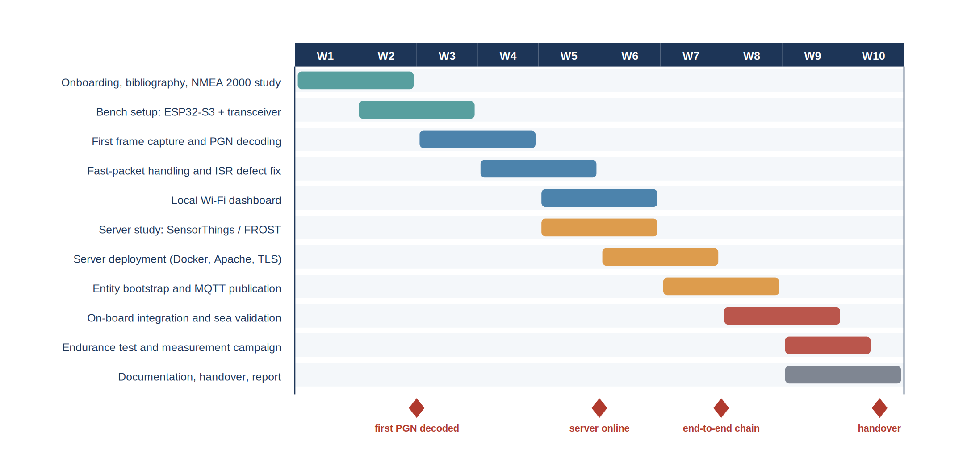
Figure 18: Planning of the ten weeks, with the milestones actually reached
The initial planning followed the decomposition presented in Section 5.1: two weeks of study and bench setup, four weeks on the vessel side, three weeks on the shore side, and one week of integration and documentation. That sequence was modified three times.
The first modification concerns the shore side, which was brought forward by approximately one week. The reason is a dependency that had been underestimated: obtaining the server access, the domain name and the firewall configuration involves an administrator whose availability is not aligned with the project schedule. Starting the request early, and working on the local components while waiting, converted a potential blocking point into a period of parallel work. The general form of that lesson, namely that a task whose duration depends on a third party should be started as early as its inputs allow rather than as late as its outputs permit, is the principal project management outcome of the internship.
The second modification concerns the debugging of the reception path, which consumed about a week more than planned. That overrun was absorbed by reducing the scope of the local dashboard, which was initially intended to include a chart of the recent history of each quantity and was reduced to the display of the instantaneous values and their age. The arbitration was made explicitly with the tutor, on the grounds that the dashboard is a convenience for the crew whereas the integrity of the decoded data conditions everything downstream.
The third modification concerns the scope itself. The survey of the network showed that the engine is not connected to the backbone, so the engine parameters, which were part of the initial request, could not be acquired with the existing equipment. The time planned for the engine decoding was reallocated to the positioning data, the AIS reports and the validation on board, and the engine gateway was recorded as the first perspective of the project. Had the survey been carried out in the first week rather than after the decoding work had started, that reallocation would have been made several days earlier.
Table 18: Deviations from the initial plan and their treatment
Event | Effect on the schedule | Decision taken
Server access granted later than requested | potential blocking of the shore-side work | shore-side tasks brought forward, request issued in week 3 rather than week 5
Intermittent corruption of positions on the complete backbone | approximately one week of additional debugging | scope of the local dashboard reduced, history chart deferred
GNSS time message not received during the first bench tests | two days lost waiting for a source assumed to be available | fallback on network time synchronisation, origin of the time reference made visible in the diagnostics
Engine not connected to the backbone | engine decoding work without object | scope revised with the tutor, time reallocated to positioning, AIS and validation, engine gateway recorded as a perspective
AIS transponder inactive at bench level | validation of two parameter groups deferred | corresponding tests moved from level 1 to level 2, dockside

6.4 Risk management
Seven risks were identified at the beginning of the project and reassessed at each weekly review. Their position in a probability and impact plane is given below, together with the mitigation that was applied.
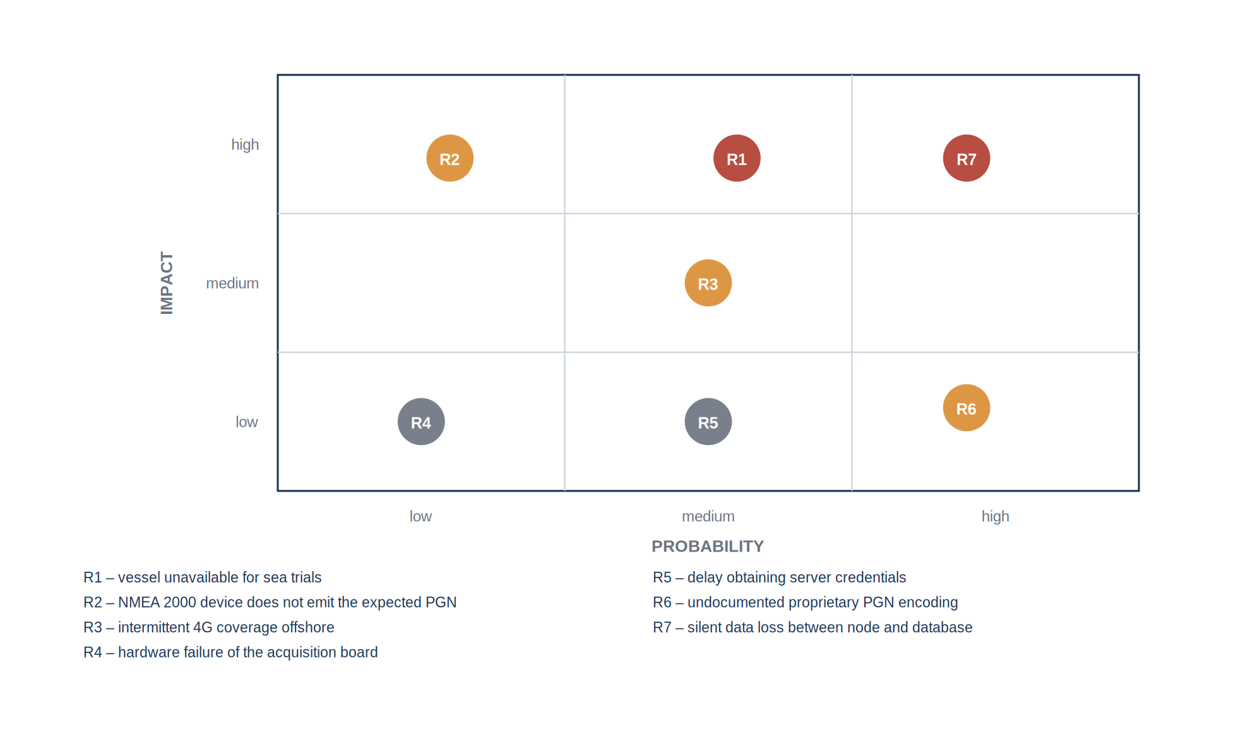
Figure 19: Risks identified at the start of the project and their assessed severity
Table 19: Risk register and mitigation
Ref. | Risk | Mitigation applied
R1 | The vessel is unavailable during the window planned for the sea trials | bench and dockside levels defined so that they validate everything that does not require movement, sea trial reduced to the irreducible tests
R2 | A device does not emit the parameter group expected from it | early inventory of the groups actually observed on the bus, before any decoding work
R3 | Intermittent mobile coverage offshore | acquisition and local dashboard made independent of the uplink
R4 | Hardware failure of the acquisition node | second board assembled and kept configured as a spare
R5 | Delay in obtaining the server credentials | request issued early, local development environment used in the meantime
R6 | Proprietary encoding of a manufacturer-specific field | scope limited to the standard parameter groups, deviation documented
R7 | Silent loss of data between the node and the database | periodic verification of the last stored timestamp, reported in the diagnostics

Three of these risks materialised. Risk R2 materialised in its most complete form: the engine does not emit any message on the network, and the mitigation, an early inventory of the traffic, is what turned a long search into a clear decision. Risk R5 was anticipated and its mitigation is the schedule change described above. Risk R7 materialised in the form of the missing feature of interest, which caused every observation to be rejected while the node reported a successful publication; that is precisely the failure mode that the mitigation was designed to detect, and it was detected by it.

6.5 Handover
A project carried out during an internship is only useful to the host laboratory if it survives the departure of its author. Three deliverables were prepared for that purpose: the version-controlled repository containing the firmware, the provisioning scripts and the deployment files; a written procedure describing the installation of the node on a new vessel, from the wiring to the declaration of the datastreams; and the present report. The identifiers of the entities created on the production server, and the correspondence between each datastream and its source parameter group, are recorded in the annexes so that the installation can be reproduced or extended without reading the firmware.

7. Conclusion
The object of this work was to make the measurements circulating on the NMEA 2000 network of a working vessel available in the scientific database of the laboratory. That objective was reached for the data that the network actually carries. An acquisition node based on an ESP32-S3 microcontroller is connected to the backbone of the vessel through a T-connector and a CAN transceiver; it listens without ever transmitting and without drawing power from the bus. It decodes the position, the course and speed over ground, the time and the quality of the fix sent by the GNSS receiver, as well as the AIS reports of the surrounding traffic when the backbone is powered, and sends them through the on-board 4G router to the database already used for the OBSEA observatory. Position observations were confirmed in the production database at one value per second. A local page served by the node gives the crew the same values without depending on the mobile network.
The survey of the network was the decisive step of the project. It showed that a single device, the GNSS receiver, was transmitting on the backbone with the ignition on, that the AIS transponder only appears when the backbone itself is supplied with 12 V, and that the engine is not connected to the network at all: its data travel on a dedicated harness to the helm display. The engine parameters of the initial request could therefore not be acquired with the existing equipment. That result was not a failure of the acquisition chain but a finding about the vessel, and it defined the scope of the work and its first perspective.
Reaching the final result required solving about a dozen problems, from the wiring of the transceiver to the declaration of the vessel in the database. Each was solved by isolating one element at a time and checking the correction on the complete network. The corresponding rules, starting with the survey of the traffic before any decoding work, are written in an installation procedure that allows the node to be installed on another vessel without the author.
Three limitations remain. The engine data, the heading and the speed through the water are not available on the network. The values acquired outside mobile coverage are not transmitted. The status of the depth transducer on the backbone remains to be confirmed [TO COMPLETE].
The perspectives follow directly. An engine gateway connected to the backbone would give the engine speed, temperatures and alarms; the node and the database are already configured for them, so only the gateway and a configuration update are needed, for an estimated cost of [TO COMPLETE: price of a suitable gateway] and one to two days of installation and testing. A heading sensor on the backbone, completed by a speed log, would give the heading and the speed through the water, and therefore the current. A small memory added to the node, of the order of two euros, would store the values acquired outside coverage and send them when the link returns; the development is estimated at one to two weeks. Finally, the replication of the installation on other vessels of the laboratory is now a matter of assembly and configuration, for a material cost of the order of fifty euros per node excluding the router.
Once the engine data are available, their joint use with the speed over ground will give access to the fuel consumption of the vessel as a function of its speed and of the sea conditions, which is the first use of the data identified by the laboratory.

Bibliography
[1] National Marine Electronics Association, "NMEA 2000 Standard for Serial-Data Networking of Marine Electronic Devices", version 1.301, NMEA, Severna Park, MD, USA, 2010.
[2] International Organization for Standardization, "ISO 11783-3: Tractors and machinery for agriculture and forestry — Serial control and communications data network — Part 3: Data link layer", ISO, Geneva, Switzerland, 2018.
[3] Open Geospatial Consortium, "OGC SensorThings API Part 1: Sensing Version 1.1", OGC 18-088, 2021. [Online]. Available: https://docs.ogc.org/is/18-088/18-088.html
[4] Fraunhofer IOSB, "FROST-Server documentation", 2024. [Online]. Available: https://fraunhoferiosb.github.io/FROST-Server/
[5] Espressif Systems, "ESP-IDF Programming Guide, Two-Wire Automotive Interface (TWAI)", version 5.5, 2024. [Online]. Available: https://docs.espressif.com/projects/esp-idf/
[6] T. Lappalainen, "NMEA2000 library for Arduino and ESP32", GitHub repository, 2024. [Online]. Available: https://github.com/ttlappalainen/NMEA2000
[7] Texas Instruments, "SN65HVD23x 3.3-V CAN Bus Transceivers", datasheet SLOS346R, 2019.
[8] OASIS, "MQTT Version 3.1.1 — OASIS Standard", 2014. [Online]. Available: https://docs.oasis-open.org/mqtt/mqtt/v3.1.1/os/mqtt-v3.1.1-os.html
[9] J. del Río et al., "The New Seafloor Observatory (OBSEA) for Remote and Long-Term Coastal Ecosystem Monitoring", Sensors, vol. 11, no. 6, pp. 5850–5872, 2011.
[10] SARTI, "Remote Acquisition and Data Processing Systems — research group presentation", Universitat Politècnica de Catalunya. [Online]. Available: https://eel.upc.edu/en/research/folder-groups/sarti-remote-acquisition-and-data-processing-systems
[11] OBSEA, "Expandable Seafloor Observatory — overview", Universitat Politècnica de Catalunya. [Online]. Available: https://obsea.es/about/overview.php
[12] Kvaser, "NMEA 2000 higher layer protocol description". [Online]. Available: https://kvaser.com/about-can/higher-layer-protocols/nmea-2000/
[13] United Nations, "Transforming our world: the 2030 Agenda for Sustainable Development", resolution A/RES/70/1, 2015.
[14] Universitat Politècnica de Catalunya, "Pla d'igualtat de la UPC", Barcelona, Spain. [Online]. Available: https://www.upc.edu/igualtat

Annexes

Annexe A — Wiring table of the acquisition node
Table 20: Connections of the acquisition node
Signal | M12 pin | Node terminal | Remark
Shield | 1 | chassis | connected at one end only
Bus power positive | 2 | not connected | the node has its own supply
Bus ground | 3 | node ground | mandatory common reference
CAN H | 4 | transceiver CAN H | white conductor
CAN L | 5 | transceiver CAN L | blue conductor
Transceiver transmit | — | GPIO5 | configured but unused, reception only
Transceiver receive | — | GPIO4 | —
Transceiver mode | — | RS to ground | selects the high-speed mode

Annexe B — Provisioning of the server entities
The following commands create the entity graph in dependency order. The identifiers returned by the server are substituted into the subsequent requests and then written into the configuration of the node.
POST /FROST-Server/v1.1/Things
{ "name": "Vessel <name>", "description": "Instrumented working vessel" }

POST /FROST-Server/v1.1/Things(1)/Locations
{ "name": "Berth", "encodingType": "application/geo+json",
"location": { "type": "Point", "coordinates": [1.7302, 41.2145] } }

POST /FROST-Server/v1.1/Sensors
{ "name": "Sportnav SPO25F", "encodingType": "text/html",
"metadata": "GNSS receiver, NMEA 2000" }

POST /FROST-Server/v1.1/ObservedProperties
{ "name": "Latitude", "definition": "http://...", "description": "Geodetic latitude" }

POST /FROST-Server/v1.1/Datastreams
{ "name": "Vessel latitude",
"observationType": "http://.../OM_Measurement",
"unitOfMeasurement": { "name": "degree", "symbol": "deg" },
"Thing": { "@iot.id": 1 }, "Sensor": { "@iot.id": 1 },
"ObservedProperty": { "@iot.id": 1 } }
The Location must exist and be linked to the Thing before any observation is published. Without it the server cannot generate the FeatureOfInterest and every observation is rejected.

Annexe C — Publication payload
Each observation is published on the topic associated with its datastream, with the following payload. The timestamp is the acquisition time recorded by the node, not the publication time.
topic: v1.1/Datastreams(3)/Observations
payload: { "result": 41.21453, "phenomenonTime": "2026-07-14T09:31:22Z" }

Annexe D — Decoding of a parameter group
The following extract illustrates the decoding of the position rapid update group. The reserved value test rejects the pattern that the standard defines as "data not available", which would otherwise be published as a valid coordinate.
/* PGN 129025 - Position, Rapid Update - single frame, 8 bytes */
static void decode_129025(const n2k_frame_t *f, vessel_state_t *st)
{
int32_t lat_raw = le32(&f->data[0]); /* 1e-7 degree units */
int32_t lon_raw = le32(&f->data[4]);

/* reserved pattern: quantity not available on this device */
if (lat_raw == INT32_MAX || lon_raw == INT32_MAX) {
st->pos.rejected++;
return;
}

st->pos.latitude = lat_raw * 1e-7;
st->pos.longitude = lon_raw * 1e-7;
st->pos.timestamp = now_utc(); /* NTP-disciplined clock */
st->pos.valid = true;
}

Annexe E — Bill of materials and indicative cost
Table 21: Indicative cost of one acquisition node
Item | Quantity | Indicative unit cost
ESP32-S3 development module | 1 | [TO COMPLETE]
SN65HVD230 transceiver board | 1 | [TO COMPLETE]
M12 five-pin drop cable | 1 | [TO COMPLETE]
Enclosure and mounting | 1 | [TO COMPLETE]
12 V to 5 V regulator | 1 | [TO COMPLETE]
Total per node, excluding the on-board router | — | [TO COMPLETE]

Annexe F — Photographic record

[ INSERT: Photograph of the acquisition node, enclosure open ]
Figure 20: Acquisition node: microcontroller module, transceiver and M12 connection

[ INSERT: Photograph of the NMEA 2000 backbone, T-connectors and terminators ]
Figure 21: Backbone of the vessel with its T-connectors and terminating resistors

[ INSERT: Screenshot of the local dashboard in operation ]
Figure 22: Local dashboard displaying live values during a sea trial

[ INSERT: Screenshot of the database response to a REST query ]
Figure 23: Observations retrieved from the production database over the REST interface
Abstract
Recent working vessels carry an NMEA 2000 network, the standard marine bus that links the navigation equipment on board. The data it carries are displayed and then discarded. This report describes an acquisition chain that makes them available in the scientific database of the SARTI research centre of the Universitat Politècnica de Catalunya. An ESP32-S3 node, connected to the backbone through a CAN transceiver, listens without transmitting and without drawing power from the bus. A survey of the traffic showed that only the GNSS receiver transmits with the ignition on, that the AIS transponder appears only when the backbone is powered at 12 V, and that the engine is not connected to the network. The node therefore acquires the position, course and speed over ground, time and fix quality, and the AIS traffic, and sends them through a 4G router to the OGC SensorThings database of the OBSEA observatory, at one value per second. A local page gives the crew the same values. The report details the equipment, the physical network, the survey, the problems met from the wiring to the database and their resolution, and the perspectives, starting with an engine gateway.
Résumé
Les navires de travail récents embarquent un réseau NMEA 2000, le bus marin normalisé qui relie les équipements de navigation. Les données qui y circulent sont affichées puis perdues. Ce rapport décrit une chaîne d'acquisition qui les rend disponibles dans la base de données scientifique du centre SARTI de l'Universitat Politècnica de Catalunya. Un nœud ESP32-S3, raccordé au bus par un émetteur-récepteur CAN, écoute sans émettre et sans prélever d'alimentation sur le bus. Un relevé du trafic a montré que seul le récepteur GNSS émet contact mis, que le transpondeur AIS n'apparaît que lorsque le bus est alimenté en 12 V, et que le moteur n'est pas raccordé au réseau. Le nœud acquiert donc la position, la route et la vitesse fond, l'heure et la qualité du point, ainsi que le trafic AIS, et les transmet par un routeur 4G vers la base OGC SensorThings de l'observatoire OBSEA, à raison d'une valeur par seconde. Une page locale restitue ces valeurs à l'équipage. Le rapport détaille les équipements, le réseau physique, le relevé, les problèmes rencontrés du câblage jusqu'à la base de données et leur résolution, ainsi que les perspectives, à commencer par une passerelle moteur.
Keywords / Mots-clés
NMEA 2000, CAN bus, marine electronics, GNSS, AIS, ESP32-S3, network survey, OGC SensorThings API, OBSEA.

